**CS 2302 Data Structures**

**Fall 2019**

**Lab Report #5**

Due: November 1, 2019

Professor: Olac Fuentes

TA: Anindita Nath

**Introduction**

Lab 5: Hash Tables focuses on developing a program that will store word embeddings in a hash table with chaining or linear probing based on the user’s preference. The user is also able to select the hashing function for the hash table. After storing the data in the chosen data structure, the similarities between the pairs of words are computed. The word pairs are located in a file which contains two words per line, separated by commas. The user can also select to input two words to be analyzed rather than an entire file of word pairs. In order to identify the similarities between the words, their vectors must be compared. Thus, the program will search the hash table to find the two words and retrieve the emb attribute from the WordEmbedding object. In order to compare the words, the cosine distance is used. In order to find the cosine distance, the dot product of the first embedding and second embedding is divided by the magnitudes of the first embedding and second embedding. The efficiency of the hash tables and hash functions are then compared by analyzing the runtimes for construction and computation of similarities. Since a major theme of this lab was to compare the different data structures, the runtimes for the B-Trees and BSTs obtained from Lab 4 are compared.

**Proposed Solution Design and Implementation**

**Overall Design**

This lab consists of four files: HashTableLPClass.py, HashTableChainClass.py, WordEmbedding.py, and NicholeMaldonado_Lab5.py. HashTableLPClass.py, HashTableChainClass.py, and WordEmbedding.py contain the designated class as well as any specific methods that are related to the class. For example, the word embedding insertion method and find methods are included. The main part of the program lies in the NicholeMaldonado_Lab5.py. This portion of program signals the actual creation of the hash table and interprets the user’s input. It is essentially the backbone of the lab. I decided to use four files to keep all of my classes separated and organized. Lab 4 had different files for each class, so I wanted to keep the designs as consistent as possible. This was crucial to evaluating the overall performances between the different data structures.

**Part 1**

Main Design

Based on the described output, the main functionality of the program builds a hash table with linear probing or chaining. The hash function used by the table is designated by the user. The user also selects whether they want to insert a pair of words or input a large list of words through a file. The chosen hash table with the hash function will then be filled with the embeddings and each pair of words are retrieved from the table. The similarities of each word pair are calculated and then displayed. During the program, the runtime for the table’s construction and search are also exhibited. Since two files are needed, I decided to first have the program prompt the user to enter the file path for each file or pair of words. After receiving the file paths, each path is first checked to ensure that it is a .txt file. I thus, used the same method from Lab 1 in order to ensure that the program would not attempt to open some other miscellaneous file, like a .jpg for example. The user is then given the option to use a hash table with chaining or linear probing to store the word embeddings and later retrieve them. I therefore created two separate functions, chaining_analysis and linear_probing_analysis, which both perform the same tasks but for the different tables. I enclosed each method call around a try block, in the event that an error occurred while trying to access any of the two files. For the chaining_analysis and linear_probing_analysis, the file paths, the designated hash function number, and load factor were accepted as parameters. For the load factor, the user could select to have a factor of 0.9, 0.75, 0.5, and 0.27. By having this capability, the effects of a table’s load factor would later be analyzed. As for the hash function number, they are based on the following: (1) length of the word (2) ascii value of the first letter (3) ascii value of the first and last letter (4) ascii sum (5) a recursive Horner’s method (6) custom. Both functions would then call their corresponding hash table “setup” function where the tables would be created and populated. After the hash table was created, it would be returned to the method. If the user had decided to compare the word pairs from a file, then the corresponding find_similarities_file function would be called. This function would find the similarities and return the runtime. If the user had entered their own pair of words, the corresponding find_similarities function would be called. This function would also compute the similarity between the words and return the runtime. The runtime would then be printed, and the program would terminate. Since the find function for the hash table with chaining requires an additional parameter, the find functions were separated in the main program.

**Part 2**

Custom Hashing Function

For my hashing function, I first researched online the way to best obtain a hashing function. Many authors stressed the importance of creating a unique hashing function that would map a limited number of keys to an index. From my research, I learned about three different hashing functions: Horner’s method, the multiplication method, and Murmurs hashing function. Initially, I was going to use Horner’s method which is essentially a polynomial where the coefficient is usually a prime number in the form of a + ax + ax^2 + …. In this example, “x” would be the ascii value of the word. After researching more about this function, I realized that the recursive function was essentially applying Horner’s method. I then looked at the multiplication method which is primarily used for integers. However, this method would be crucial for my own method creation because I realized that multiplying by a coefficient was used in this method as well as Horner’s method. From the murmur method, I saw different values being appended and XOR operations being applied. I thus decided to combine Horner’s method with the murmur method.

For my method, I chose a coefficient of 133 and obtained the value of 133 to the ith power times the ascii value of the current character. This part is similar to Horner’s method. Then, since I realized that the Murmur method was using bit manipulation, I decided to XOR the term described above with 37 to the ith power. The reason why I choose 37 to the ith power was partly due to the multiplication method which uses a constant prime value. I chose to make it the ith power since the length of the words could vary and a letter at a specific index could easily vary amongst the other words. When testing my hashing function, I also printed the binary numbers calculated. From these results, I continued to change my design until I got a wide array of bit lengths. The current custom implementation has some binary numbers with more than 78 bits which results in more than 3.02 E 23 possible combinations. This in turn validates the hash functions ability to generate unique keys. Initially, I had just calculated the summation of the ascii values times the position, however the running times were too long. From this trial, however, I learned that the position of the character can have a large role in making a hashing function map keys to different indices. Lastly, I also tried switching the bits for the first ascii value of the word by using the “<<” operator. This resulted in a longer running time, so the idea was abandoned.

Hash Table with Chaining Construction

The main construction method for the Hash Table with chaining is file_to_chaining. This function takes the file path of the glove.6B.50d.txt file, the hash function number, and the load factor as a parameter. Unlike the BST and B-Tree, the Hash Table requires a predetermined size. In order to determine the table size with the required load factor, the user can denote how many valid lines of words the file contains or allow the computer to automatically count the number of valid lines. By allowing the user to enter the number of lines, I realized that the incorrect number of lines could easily be entered. In order to preserve the load factor, I therefore added a line counter that would ensure that when populating the table, only a fixed number of words would be inserted. This fixed number of words was based on the number of words that would match the load factor. If the user decided to allow the number of lines to be calculated, then the program will read the file and count the number of non-white space lines, with a lettered word as the at the front of the line. This was a very important design decision because if just the number of lines were calculated, then the load factor of the table could be affected. The glove.6B.50d.txt file includes words with punctuation that will not be inserted. Thus, if these words were also taken to account, then the load factor of the table would be smaller than the intended factor. Although reading the file twice is not optimal, it is necessary if the user does not know the number of words to be inserted into the table. Thus, I decided to avoid this situation by allowing the user to enter the number of valid lines. This method also has its own pitfall since an additional safeguard needs to be added while reading the file since the user could accidently put less than the actual number of valid words that the file can contain. This is why the line counter is crucial implementation. Initially, I was going to hardcode a table size, but I realized that the size of the glove.6B.50d.txt file would change to accommodate the long running times for the Hash Table with linear probing. Another solution that I thought of required resizing the hash table. However, this would result in O(n) runtime, which is equivalent to reading the file once and then rereading the file to populate the table. Additionally, if the table was resized for the last element, then the load factor could change from 0.75 to 0.5 for example. This would defeat the entire purpose of testing the load factors. Thus, I decided to choose my initial idea.

Once the total number of lines are calculated, the Hash Table is created with the size assigned to the number of lines divided by the load factor. The file is then read from the beginning. As each line is read, it is processed and turned into a WordEmbedding object. The line is first striped of any newlines. A check also ensures that the word only contains letters. After the line is checked, it is split by spaces into a list. The word of the WordEmbedding object is then assigned to the value at index one and the emb attribute is assigned to the rest of the list. With the WordEmbedding object created, it is then inserted into the Hash Table.

The insert function for the Hash Table with chaining is fairly straightforward. It takes the word embedding, hashing function number, and an ordered boolean as parameters. Based on testing, it was determined that for hash functions 5 and 6, the elements could be inserted linearly, staying true to the definition of a hash table. However, for hash functions 1 through 4, the user is given the option of whether to insert the WordEmbeddings in order, or to use the regular insertions. Thus, the ordered Boolean determines whether the binary insertion function or linear insertion function should be called. The binary insertion function is the same method used in Lab 5 for the B-Tree. Just as the B-Tree had a list of data, each bucket has a list of data. By calling this method, the word embedding is placed in its correct ordered position if it does not already exist in the list. Using the binary insertion was a very important design decision that I made. Initially, I was just checking each element and if the new element did not exist it was appended to the list. However, when applying the linear insertion on the hash functions 1 through 4, the running time was large due to the collisions. I realized that by inserting the elements in order, then duplicates could easily be checked for while the elements were being inserted. Consequently, the insertion of elements went from more than 40 seconds to approximately 10 seconds. Thus, I realized that if I order the data as I am inserting it, the find operation would be easier resulting in faster running times. However, it was also noted that the user may later want to extract the order of collisions. In order to fulfill this requirement, the user can decide to use the regular linear insertion that will check the elements one by one before inserting.

After all the lines were read and all the WordEmbedding objects were added to the hash table, I returned the hash table, performance time, and whether the individual chains were ordered. The performance time was calculated by subtracting the time the first line of the file was read to the end of the iterations.

As for the efficiency of the function, m WordEmbeddings will be added to the hash table. Thus, the insertion method will be called m times. The insertion method will then call the linear insertion method of the binary insertion function based on the hash function. If linear insertion was selected, the runtime would be O(d) where d is the number of elements at the chain. Since the chains for hash functions 5 and 6 are short, the insertion is almost in constant time. As for binary insertion, the designated bucket will repeatedly divide the list in half until the WordEmbedding’s correct insertion place is found. This single process results in O(logd) time where d is the number of elements in the bucket. Although hash tables are supposed to have insertions and finds in constant time, it is important to note that the O(logd) time is preferable for hash tables with larger collisions. As the tests will later demonstrate, these chains can become extremely long, sometimes reaching 700 elements. By ordering these elements as they are inserted, one can avoid having to look through 700 elements just to find that the element is not in the bucket.

Hash Table with Linear Probing Construction

The main construction method for the hash table with linear probing is file_to_linear_probing. This method takes the file path of the glove.6B.50d.txt file, the hash function number, and the load factor as the parameter. Similar to the hash table with chaining, the user is able to enter the number of lines that the file contains or have the computer automatically calculate the number of valid lines. The number of lines is then divided by the load factor, designated by the user, and applied as the size attribute of the table. Each line of the file is read one at a time. Similar to the all previous implementations, as each line is read, it is processed and turned into a WordEmbedding object. The line is striped of any newlines and is checked to ensure that the word only contains letters. The word_embedding object and hash function number are passed as parameters.

The insertion method for the Hash Table with Linear Probing is the same code provided in class, however it has some adjustments. Since the values that we have worked with in class are integers, the next bucket to be analyzed can easily be computed by calling the hash function and passing in the value as well as the current index i. Since word embeddings are being inserted, the word and i cannot simply be passed to the hash function to reach the next bucket. Thus, I assign the position to bucket where the value is mapped and then for every value of i after 0, the position is updated to the next bucket. Since duplicates are not allowed, I first check if the current element’s word is the word to be inserted. If it is, then -1 is returned. It is crucial to note that the item attribute contains a list of -1’s and word embedding objects. Thus, if an exception is thrown while trying to access the elements word attribute, the exception is caught. This exception clearly denotes that the element is an integer and therefore the WordEmbedding object is inserted and the position is returned.

After all the WordEmbedding objects are inserted, the hash table and the performance time are returned. The performance time was also calculated by subtracting the time of the first line read from the end of all the iterations.

As for the efficiency of the function, m WordEmbeddings will be added to the hash table. Thus, the insertion method will be called m times. In the best case scenario, the correct bucket will be found and the WordEmbedding object will be inserted in constant time. However, as future tests will demonstrate, based on the hash function, the scenarios can change. If more elements are hashed to an index, more collisions will occur resulting in longer insertion times, since the list has to be iterated through until an integer is reached. In the worst case, one could assume that a numerous amount of collisions have occurred, resulting in the entire list to be iterated through.

**Part 3**

Compute Similarities

In order to compare the similarities, the compute_similarity function is called. This function takes the two vectors of the WordEmbedding objects as parameters. The dot product, obtained by using np.dot(), is then divided by the magnitude and returned. The magnitude is obtained by multiplying the result from the np.linalg.norm() function from the vectors.

Find Function

The main method for reading a file containing the word pairs and finding the similarities for both hash table implementations is the corresponding find_similarities_file function. The find function for linear probing takes the hash table, file path for the word pairs, and hash function number as parameters. The find function for chaining has the same parameters but it also includes a Boolean which determines whether the words will be found through binary search or linear search. As each file line is iterated through, the current pair of WordEmbeddings are found in the hash table. The vectors of the embeddings are then compared using the function described above. Additionally, as each line is read, the words and their similarities are added to a list. When all the pairs have been evaluated, the similarities are then displayed to the screen. I did this to make the BST, B-Tree, and hash table implementations as similar as possible. The performance time was calculated from the start of the file iteration to the end was then returned. One change that I did make was to create an additional hash table object called index_usage_hash_table. This hash table was used to count the number of times an index was referenced. Thus, before the find operation occurred, I initialized this hash map to be the same length as the populated hash table. Then, when a specific bucket was searched for, the value at the index in the index-usage_hash_table was incremented. This hash table would later be evaluated to find the bucket that contained the largest integer, designating the most viewed bucket. This was an important design decision that I made because I did not want to create a global hash table that would update every time an index was accessed. Thus, I made the hash table’s update as simple as possible so it would not affect the performance time for the main populated hash table. I also ran the code with and without the index_usage_hash_table and found that the object did not affect the overall performance time.

If the user had entered a pair of words rather than a file, then the corresponding find_similarities function was called. This function also contained the same parameters as those noted above for the find_similarites_file functions.

Hash Table with Chaining Find

In order to find the word_embedding in the hash table, the function find was used. This method took the word, hash function number, index usage hash table, and Boolean value denoting which find to perform as parameter. The function would return emb attribute of the WordEmbedding if it was found. If the word was not found, then None was returned. The find function would immediately call the find_binary_search function if the table had ordered chains. This function would perform binary search on the chain. The correct hash function was called based on the hash function number. For hash functions 5 and 6 or table’s with unordered chains, the find_linear function would be called since the hash table populated with hash functions 5 and 6 is not ordered.

As for efficiency of the function, the binary search function for the hash table will repeatedly divide the list in half until the word embedding is found or the start index is greater than the end index. This results in a runtime complexity of O(logd) where d is the number of elements in that bucket. Since m pairs are read from the file, two calls to the search method will be made resulting in O(logd1) + O(logd2) were d1 is the number of elements in the first bucket and d2 is the number of elements in the second bucket. Thus, in total, the runtime complexity will be O(m * logn) where m is the number of pairs read from the file and n is the average number of words that a bucket can contain. If the elements were found with the linear search function the total runtime complexity would be O(m * d) were d is the largest number of elements from the first or second bucket checked. Although one may question why the binary search function was not used on all hash functions, it is because the number of collisions vary largely amongst the hash functions 1 to 4 and 5 to 6. Hash function 5 and 6 had minimal collisions resulting in WordEmbedding finds that could be achieved in nearly constant time. Additionally, by allowing users to choose the implementation, the different results could be analyzed.

Hash Table with Linear Probing Find

In order to find the WordEmbedding in the hash table with linear probing, the method find was used. This method took the word, hash function number, and index usage hash table as a parameter and returned the emb attribute of the WordEmbedding found. If the word was not found, then None was returned. Similar to the insertion method, the buckets were iterated by first finding the initial bucket and then updating the position to the next bucket in the list for each iteration. If the current element in the list was the word, then the embedding was returned. Since all the elements in the list are not WordEmbedding objects, I included an except statement. If an exception was thrown while attempting to access the elements word attribute, then the element must be an integer. If the element was -1 then all searches stopped, and None was returned. Using the try and except statements were a very important design decision. At first, I was going to check the type of the element, but I realized that this is not the most suitable solution. Thus, I decided to use try and excepts which would clearly demonstrate whether the current element was an integer or WordEmbedding object.

As for efficiency, the search function for the hash table, in the best case, will immediately find the word embedding in the corresponding bucket. This would result in constant time. However, if multiple collisions occur, the worst case could result in the entire list being iterated through resulting in O(n) where n is the number of elements in the list. Just like the hash table with chaining, the find method is called twice for each word. Additionally, find will be called twice for every m pairs resulting in O(m * n).

**Part 4**

Running Time Display

In order to compare the running time of the construction and similarity computation, I displayed each performance time after the operation occurred. These running times were usually returned to a method to be printed and displayed along with the other stats.

Hash Table with Chaining Stats

In order to display the stats of the hash table with chaining, I created a num_elements and num_empty_lists method. The num_elements would essentially count the number of word embeddings in the hash table. This would later be used to calculate the load factor by dividing the number of elements by the length of the list. The num_empty_list function was used to calculate the number of empty chains. In order to do so, a counter was initialized to 0. If an empty list was found, it was incremented. The num_empty_list function was very important to compare the distribution of the elements. Lastly, the maximum number of times that an index was called was also calculated by the most_used_index function. Since the index_usage_hash_table was the only object to use this function, this function was defined in the HashTableLPClass.py file when the index_usage_hash_table is a hash table with linear probing. Nonetheless, it was still integral to counting the maximum number of times that an index was referenced for the hash table with chaining. Although the number of lines is calculated in the insertion methods, there could be an instance in which an element was not inserted. Thus, the number of lines does not always reflect the number of elements in the hash table so the num_elements method is essential.

Hash Table with Linear Probing Stats

In order to display the stats of the hash table with linear probing, I created a num_elements function. The num_elements would essentially count the number of word embeddings in the hash table. This would later be used to calculate the load factor by dividing the number of elements by the length of the list. Additionally, since the hash table with linear probing does not have chains, the number of empty indices can also be calculated by subtracting the number of elements from the length of the table. Lastly, the most_used_index function was used to identify which index had the largest value in the table. This value corresponded to the number of times that the index was referenced during the find operation.

**Experimental Results**

For the tests, the running times for the hash table with linear probing with the following hash functions exceeded the maximum amount of time: length of the string, ascii value of the first letter, and the ascii value of the first and last letter. Due to this, a condensed glove.6B.50d.txt file was made called rsmall_glove.txt. It only contains 35% of the words from the original file. Since these four hash functions result in different word files used, the tests are separated based on the glove.6B.50d.txt file used. All of the chaining hash functions and the recursive and custom linear probing hash functions used the standard glove.6B.50d.txt file. The chaining ascii sum hash function is also included in the initial tests but is not included in the graphs because its runtimes were drastically different. When running the four chaining hash functions, it was realized that a larger file could be used to test the bounds of the hash function. Thus, a medium_glove.txt file was made which contains 45% of the words from the original file. As the tests will later show, the ascii sum and ascii first and last hash function had low run times. Thus, the ascii sum’s runtimes were also included with the tests that used the glove.6B.50d.txt. The ascii first and last hash function runtime was too long for a larger file, so its max analysis resides with the other hash functions tested with the medium_glove.txt file. Only tests for the hash table with chain with the hash functions length of string, ascii value of the first letter, ascii value of the first and last letter, and ascii sum use the medium_glove.txt file. From the tests it was indicated that searches with the four hash functions described above with linear probing could not be applied on 50,000 pairs. Thus, the tests for the four linear probing hash functions only apply to small and average sized files. In summary the following files apply to the denoted hash functions:

**glove_6B_50d.txt**

Chaining with Ordered Chains (Binary Insertions and Finds) – length of string, ascii value of the first letter, ascii value of the first and last letter, and ascii sum

Chaining Standard (Linear Insertions and Finds) – ascii sum, recursive, custom

Linear Probing – recursive, custom

**small_glove.txt – 35% of Original File**

Chaining Standard (Linear Insertions and Finds) – length of string, ascii value of the first letter, ascii value of the first and last letter, and ascii sum

Linear Probing – length of string, ascii value of the first letter, ascii value of the first and last letter, and ascii sum

**medium_glove.txt – 45% of Original File**

Chaining Standard (Linear Insertions and Finds) – length of string, ascii value of the first letter, ascii value of the first and last letter, and ascii sum

**Part 1 – Hash Table Construction:**

For the hash table construction, four tests were run for the Hash Table with Linear Probing and Hash Table with Chaining. The cases tested the following load factors: 0.9, 0.75, 0.5, and 0.27. Since the load factor denotes how distributed the elements in a table are, I thought that the different load factors may affect the running times. I chose a load factor for 0.75 because it is believed by many to be the most ideal for a hash table. Additionally, for the hash table with chaining the first table for each case denotes the runtimes for the ordered chains. The third table represents the runtimes for standard insertions.

Sample Output For Hash Table with Chaining:

Ascii Sum Hashing Function using glove.6B.50d.txt file

Load Factor – 0.75

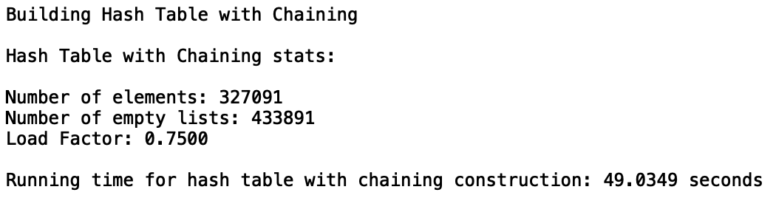

Sample Output for Hash Table with Linear Probing:

Recursive Hashing Function

Load Factor – 0.75

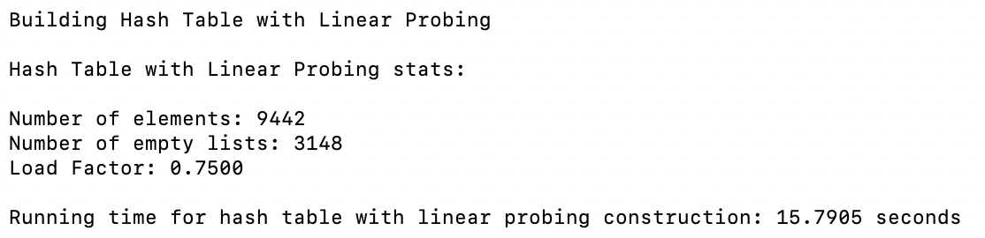

Case 1 (“0.9 Load Factor”):

pairs.txt

glove.6B.50d.txt



small_glove.txt



half_glove.txt



Case 2 (“0.75 Load Factor”):

pairs.txt

glove.6B.50d.txt



small_glove.txt



half_glove.txt



Case 3 (“0.5 Load Factor”):

pairs.txt

glove.6B.50d.txt



small_glove.txt



half_glove.txt



Case 4 (“0.27 Load Factor”):

pairs.txt

glove.6B.50d.txt



small_glove.txt



half_glove.txt



NOTE: BI stands for Binary Insertion. LI stands for Linear Insertion.







From the bar charts, it is evident that the running times slightly decreased as the load factor decreased. For example, on the first graph, the hashing function of the ascii value of the first character decreased an average of 0.02 seconds for each load factor. The largest decrease in running times was for the hash tables with linear probing. Since these hash table’s must be traversed one by one to find an empty bucket, more elements must be seen. The larger load factor decreases the table size, allowing more collisions to occur. Due to an influx of collisions, more elements must be searched in order to find an empty bucket. Additionally, it should be noted that the hash functions 5 and 6 had the largest decrease in runtime due to the load factor. This is yet again attributed to the insertion method used. For the hash table with chaining a linear insertion method was applied. Thus, by decreasing the table the recursive and custom methods hash values were adjusted and consequently mapped more elements to the same bucket. Despite the chaining recusive hash function or the linear probing custom hash function, the runtimes of the varying load factors were very similar. This may be attributed to the fact that even with a larger table, the same number of elements are still traversed. For example, the running times for the hash table with linear probing stayed the same, as demonstrated in the second graph. Since the string lengths are, on average, less than 10 characters, a major cluster formed at the beginning of the array. Thus, increasing the size of the table would not have any noticeable changes since it is highly unlike that a word of length 300,000 exists in the file and would be mapped to that index. Lastly, these charts demonstrate an interesting trade-off for hash tables. One could ultimately create larger tables, that could result in shorter construction times as seen in the first graph. In doing so, one would be using even more space that would never be filled. This results in more resources that would go unused. By decreasing the hash table’s size, however, one could witness larger construction times as seen with the linear probing. From these tests, it was concluded that the load factor of 0.75 was the most ideal. In nearly all instances the running times with a load factor of 0.75 were slightly above the running times with a load factor of 0.5. Thus, approximately the same running times could be achieved while using less space. For the hash table with chaining with the linear insertion, depicted on graph 3, the running times were low for the ascii sum and first and last ascii value. Due to this, the ascii sum function would later be used on other tests and extract pairs from the standard glove file. It is also important to note that the hash tables with ordered chains were all grouped under a single file rather than separate file sizes to allow for a better analysis.

**Compute Similarities – Provided Output:**

For the compute similarities test, two tests were run. These tests focused finding the similarities of the pairs provided in the lab. I thought that this case was very important to identify if the compute_similarity function was producing the correct results for both the Hash Table with chaining and the hash table with linear probing. The file tested for both cases is pairs.txt and can be found in the GitHub repository in the file TestTrialFiles.

Case 1 (“Chaining”):

Recursive Hashing Function using glove.6B.50d.txt

Load Factor – 0.75

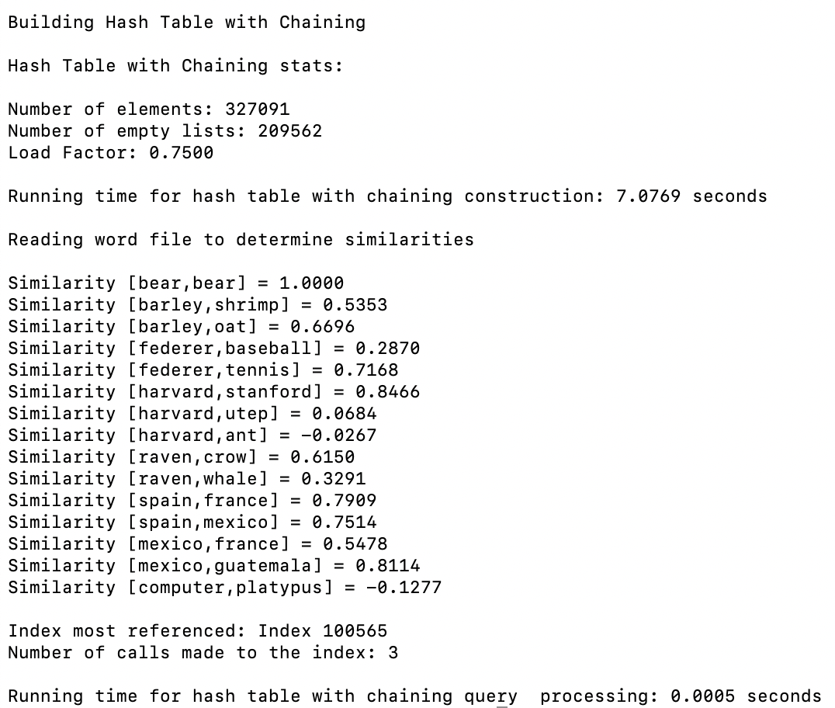

Case 2 (“Linear Probing”):

Recursive Hash Function using glove.6B.50d.txt

Load Factor – 0.75

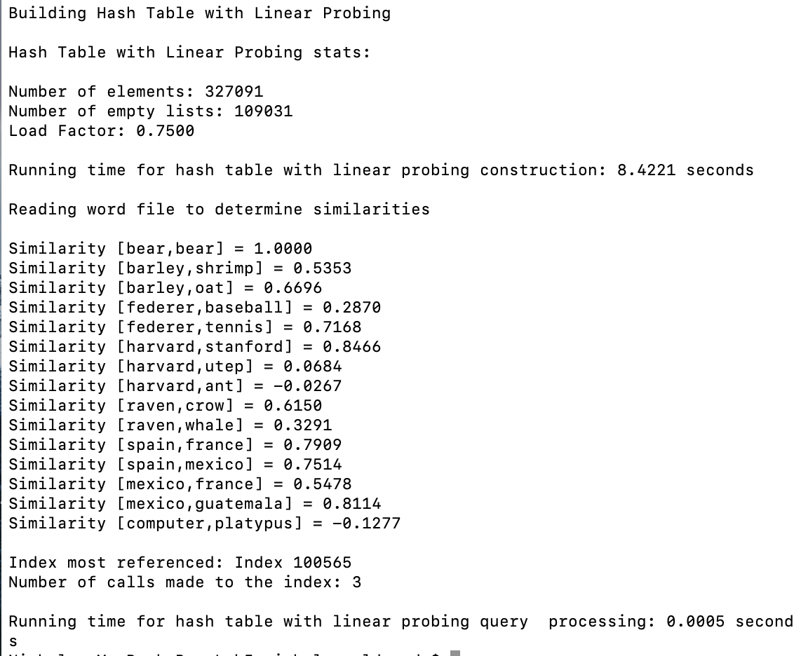

From the outputs, I was able to identify that the correct results for the similarities between the words was being computed. In doing so, I was able to focus on the running times without having to worry if the correct similarities are being computed. This test case also demonstrated that the running times for the hash tables are almost negligible since the amount of pairs are so small.

**Similarities – Small and Average Number of Pairs:**

For the Similarities test, five tests were run. These tests focused on gathering the runtime complexities for files with 100, 500, 1000, 2000, and 5000 pairs. The cases are subdivided into two categories: runtimes with the glove.6B.50d.txt file used and runtimes with the small_glove.txt file used. For the small_glove.txt file, the hash tables with unordered chaining’s were tested for hash functions 1 through 4. For the standard glove file, the unordered chains were tested for hash functions 4 to 6. The ordered chains were also tested for hash functions 1 to 4. Each test had two different trials with the .txt files corresponding to the trial number. Each .txt file contains randomly selected pairs. It is also important to note that these files were the same ones used with the trees in Lab 4 for the first table. I thought that this test was very important to identify how the trees would respond to average sizes and smaller sizes of pairs. By using the same pair files, the analysis between the different data structures would be more accurate. For the small_glove.txt file however, new test files were created and start with “LP”. The files tested can be found in the GitHub repository under the TestTrialFiles folder.

Sample Output for Hash Table with Chaining 100 pairs:

Ascii first character hash function using small_glove.txt

Insertion and Find – Linear

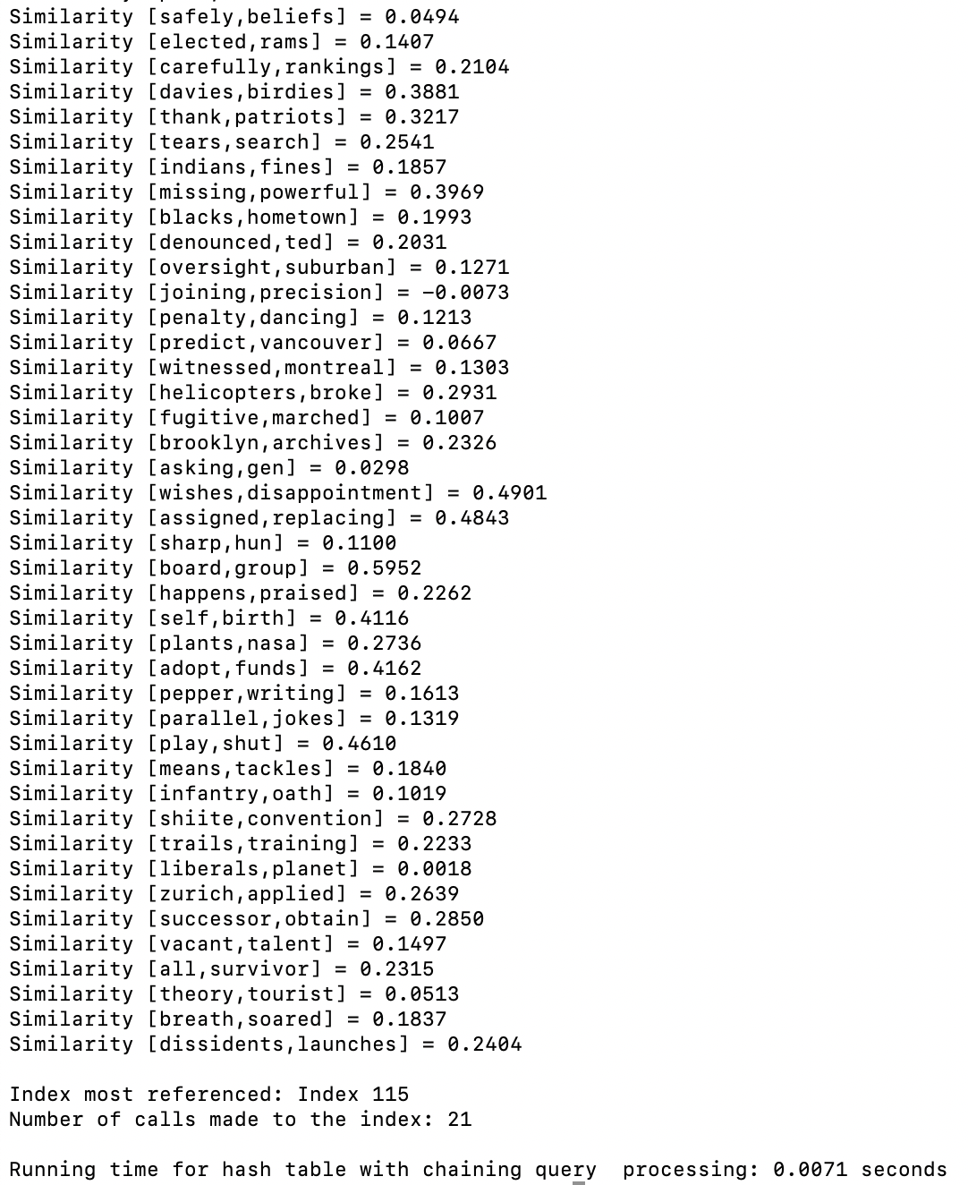

Sample Output for Hash Table with Linear Probing 100 pairs:

Ascii first character hash function using small_glove.txt

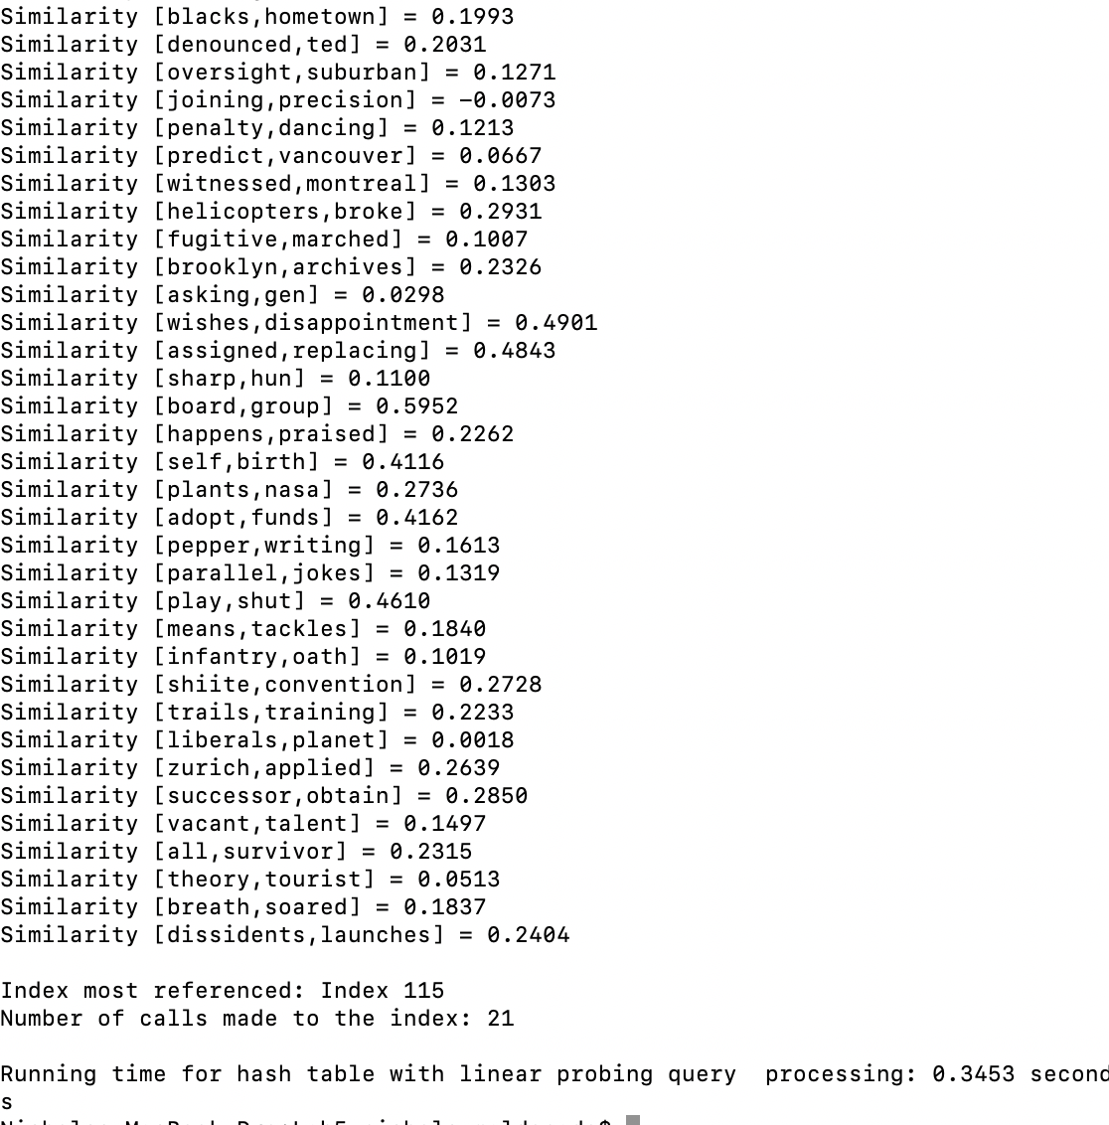

Case 1 (100):

Trial1_100.txt

Trial2_100.txt

LPTrial1_100.txt

LPTrial2_100.txt

glove.6B.50d.txt



small_glove.txt



Case 2 (500):

Trial1_500.txt

Trial2_500.txt

LPTrial1_500.txt

LPTrial2_500.txt

glove.6B.50d.txt



small_glove.txt



Case 3 (1000):

Trial1_1000.txt

Trial2_1000.txt

LPTrial1_1000.txt

LPTrial2_1000.txt

glove.6B.50d.txt



small_glove.txt



Case 4 (2000):

Trial1_2000.txt

Trial2_2000.txt

LPTrial1_2000.txt

LPTrial2_2000.txt

glove.6B.50d.txt



small_glove.txt



Case 5 (5000):

Trial1_5000.txt

Trial2_5000.txt

LPTrial1_5000.txt

LPTrial2_5000.txt

glove.6B.50d.txt



small_glove.txt



NOTE: BS stands for Binary Search. LS stands for Linear Search.





The first graph above summarizes the running times for the finding a smaller number of word pairs for the chaining hash functions that use binary search, the recursive and custom functions that use linear search, and the linear probing hash functions 5 and 6. The second graph summarizes the running times for hash functions 1 to 4 for the linear probing and chaining with linear search, since they are using the small_glove.txt. From these tests, it is clear that these four linear probing hash functions had the worst running times. Their average times were nearly identical to the other hash functions. However, the four hash functions only performed the searches on 35% of the words from the original file. As for the hash functions for chaining, their averages are minute when compared to the other four functions. This proves that the functions are able to process larger amounts of data, as later tests will show. The functions, however, are still unable to be populated by the standard glove file, shedding light on their inefficiencies. The first graph demonstrates that hash table with chaining recursive function had the best running time and the linear probing custom had the worst running time. The efficiency of the recursive function further demonstrates why Horner’s method is often used for hash functions. As for my custom hash function, viewing the graph, one may denote it as the “worst” overall. However, even though it did have the worst running times out of the 8 tested with the standard glove file, it was more consistent than a majority of the other functions. For example, the runtime for the ascii sum was the second lowest time for the hash table with chaining. For the hash table with linear probing, the program was still populating the table 30 seconds later. Thus, my custom hashing function or the recursive hash function would be better for those who wish to apply the same hashing function on both types of hash tables. As for the hash table with chaining using linear search, the ascii sum function was not plotted since its runtimes in some instances are a second longer than the others. This would have compressed the data, making it hard to visualize. The ascii sum hash function is the only ascii hash function that could populate the hash table with chaining with the standard glove file under 50 seconds. This is because a sum of character is more unique then just the first or last letter of a word.

**Similarities – Medium Files:**

For the Similarities test, two tests were run. This test focused gathering the runtime complexities for files with 50,000 and 100,000. As for the hash table with linear probing, four of the functions had 10,00 as the maximum number of pairs tested. An initial test was attempted at 50,000 but the running times were too long. Thus, the final test for the linear probing’s hash functions 1 to 4 ended at Case 1 with 10,000 pairs. Since the hash table with chaining is being compared with the corresponding linear probing values, the tests also stop after Case 1. Each test had two different trials with the .txt files corresponding to the trial number. For the test trials that used the small_glove.txt file, the test files begin with “LP”. Each .txt file had randomly selected pairs. I thought that this test was very important to identify how the hash tables would respond to medium sized data. I specifically chose these file sizes since 100,000 pairs is approximately a third of the number of words in the file. The files tested can be found in the GitHub repository under the TestTrialFiles folder.

Sample Output for Hash Table with Chaining 50,000 Pairs:

Custom hash function using glove.6B.50d.txt

Insertion and Find – Linear

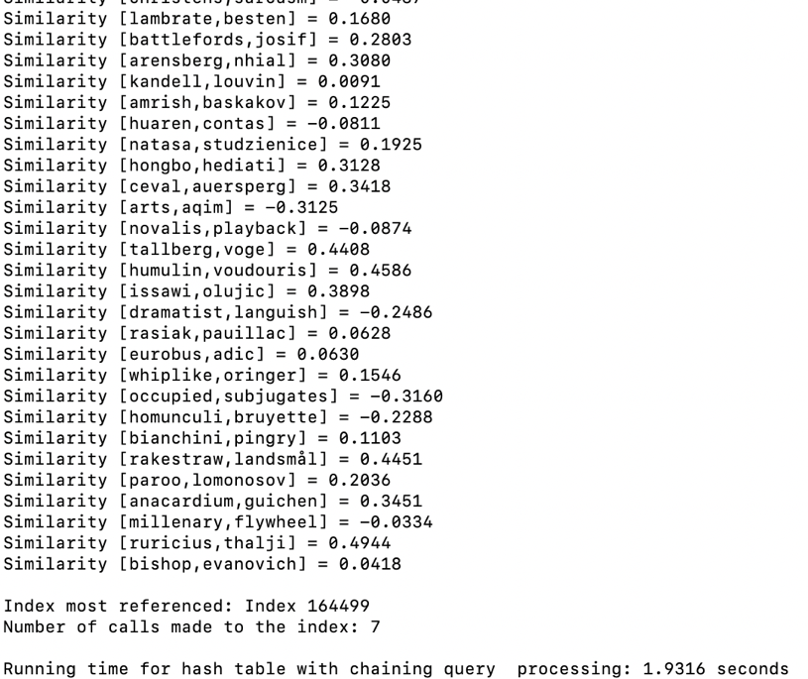

Sample Output for Hash Table with Linear Probing 50,000 Pairs:

Custom hash function using glove.6B.50d.txt

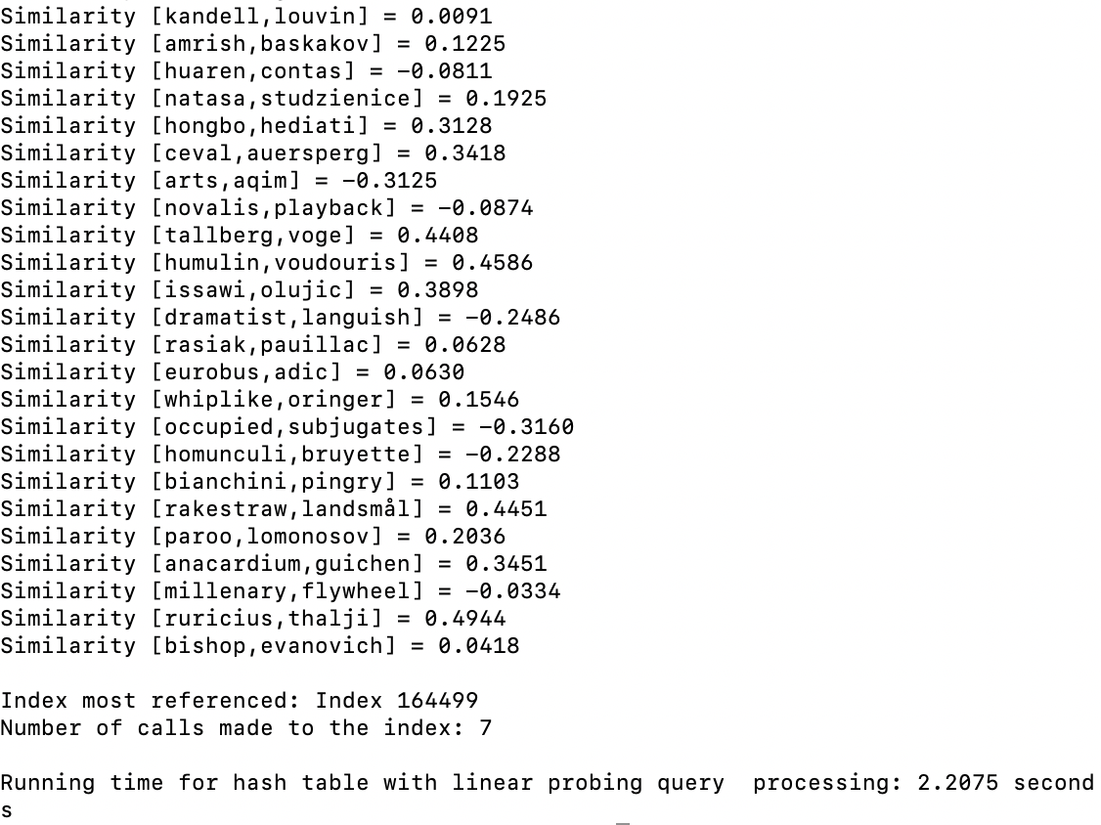

Case 1 (50,000 or 10,000):

Trial1_50000.txt

Trial2_50000.txt

LPTrial1_1000.txt

LPTrial2_1000.txt

glove.6B.50d.txt



small_glove.txt



Case 2 (100,000):

Trial1_100000.txt

Trial2_100000.txt

glove.6B.50d.txt



NOTE: BS stands for Binary Search. LS stands for Linear Search.





The first graph above summarizing Case 1, demonstrates, the runtimes for the hash tables with linear probing, chaining with linear search, and chaining with binary search. For the most part, the runtimes for the data, minus the functions depicted in the second graph, were closely related. The efficiency of recursive function was yet again evident. This is attributed to the hash functions ability to reduce collisions by hash values uniquely. The string length had some of the highest runtimes in both graphs. Since all the words were approximately the same length, more collisions occurred when inserting, resulting in slower find times. When viewing the graphs, it is also interesting to note that the hash table with chaining runtimes were lower than the corresponding hash table with linear probing. This clearly highlights an interesting benefit of using hash tables with chaining. If more collisions occur, then chaining, rather than linear probing, is most ideal. Since the individual buckets are ordered for hash functions 1 through 4, when binary search is performed, the number of elements that need to be viewed is halved. As for the linear probing, it must continue to search one element at a time. This is why the small_glove.txt needs to be used for the linear probing with hash functions 1 to 4. From the second graph, the hashing function for the ascii value of the first letter had the highest running time. Since the ascii value of letters are an integer apart, it is apparent why the runtimes are long. Lastly, from the second graph, the efficiency of the chaining function versus the probing function is apparent. By having chains of data, only those with the same hashing value are evaluated. With linear probing, other collisions from previous insertions could have occurred, resulting in even more elements seen.

**Similarities – Large Files:**

For the Similarities test, three tests were run. These tests focused gathering the runtime complexities for files with 150,000, 200,000, and 300,000 pairs. The cases tested linear probing for hash functions 5 and 6, chaining with regular insertions for hash functions 5 and 6, and chaining with ordered insertions for hash function 1 through 4. Each test had two different trials with the .txt files corresponding to the trial number. Each .txt file had randomly selected pairs. I thought that this test was very important to identify how the hash tables would respond to large sizes data. I specifically chose these file sizes since 300,000 pairs is close to the 327, 091 words in the file. I wanted to test that how each algorithm would respond if every word was nearly searched for. Since the Linear Probing’s recursive and custom hash functions were the only functions able to be tested with such large amounts of data, these tests would be integral when comparing the running times with the trees. Lastly, all the tests used the glove.6B.50d.txt file. The files tested can be found in the GitHub repository under the TestTrialFiles folder.

Sample Output for Hash Table with Chaining 300,000 pairs:

Custom hashing function using glove.6B.50d.txt

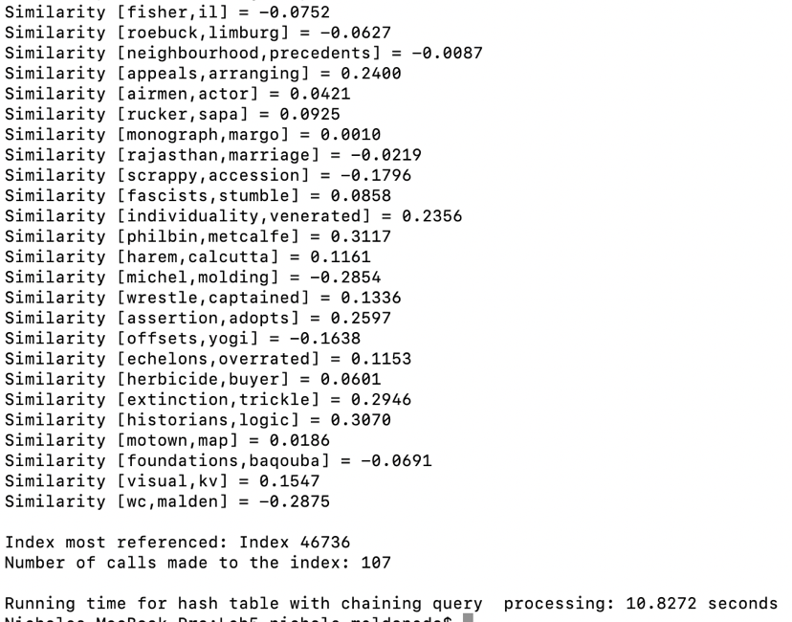

Sample Output for Hash Table with Linear Probing:

Custom Hash Function using glove.6B.50d.txt

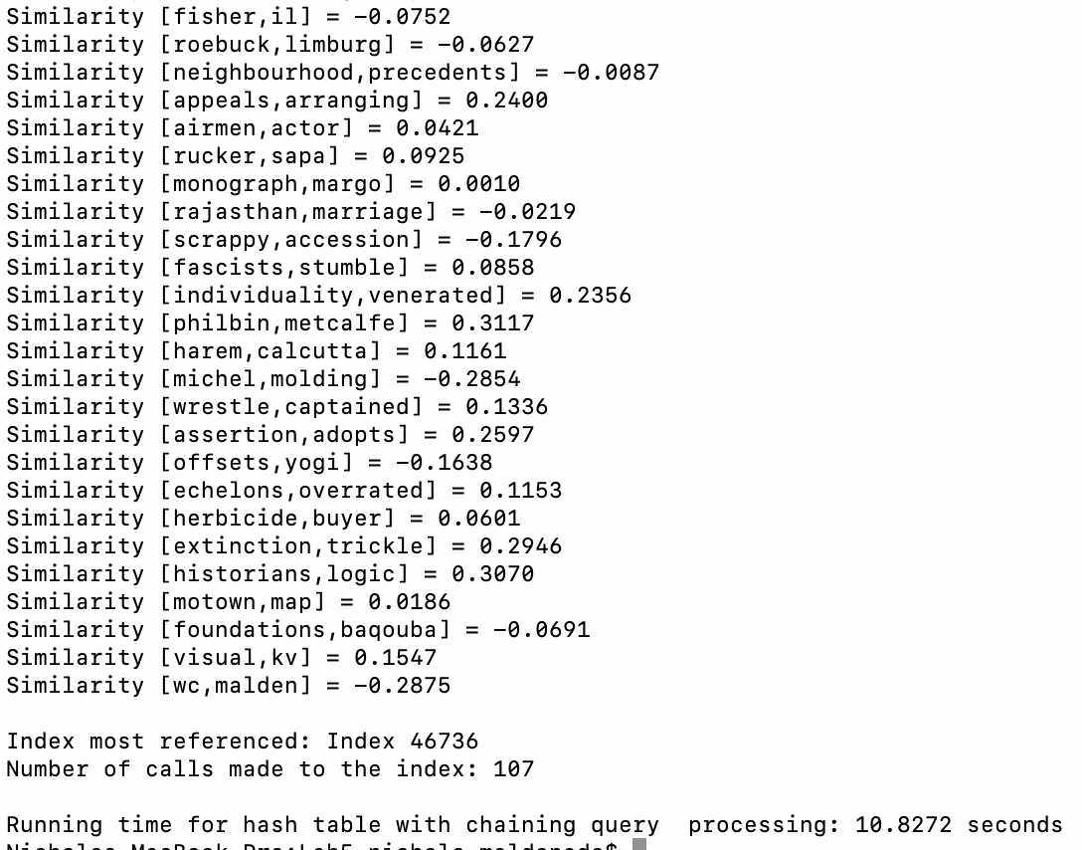

Case 1 (150,000):

Trial1_150000.txt

Trial2_150000.txt



Case 2 (200,000):

Trial1_200000.txt

Trial2_200000.txt



Case 3 (300,000):

Trial1_300000.txt

Trial2_300000.txt





The graph above summarizing Case 1 to Case 3, demonstrates the runtimes for the hash tables with chaining and linear probing. Yet again, the hash table with chaining’s recursive hash function had the lowest performance time. By obtaining a summation of the string’s ascii values as polynomials, it is less likely for multiple words to be mapped to the same index. The chaining’s string length and the linear probing’s custom hash functions had the highest runtimes. This was expected since the string length is nearly the same size for all the words. Although the linear probing’s custom function was able to be populated based on the original glove file, its inefficiency is more evident with larger values. This may be attributed to the fact that the custom hash function was a merged result the murmur hash function and Horner’s method. By converting the current summation to bits and in the end converting the result back to integers, I probably flattened the unique keys. However, it would be unfair to completely discourage the use of combining the methods since the values were consistent and able to function with the original glove file. Lastly, the chaining’s ascii hash functions with ordered chains had lower running times due to the binary search on the data. Thus, the overall efficiency of the test runs should not be purely attributed to the hash functions themselves. Since the binary search is halving the data, finding an element is achieved in a faster period of time for hash functions 1 to 4. If the individual buckets were not ordered, then the hash table chaining’s ascii functions would still be building the table while the current implementation has already built and found the necessary word pairs.

**Similarities – Hash Tables with Chaining Using Linear Find:**

For the Similarities – Hash Tables with Chaining Using Linear Find Test, three tests were run. Case 1 through Case 3 focused on finding the similarities of 500, 5,000, and 50,000 pairs. Since the tests for the hash tables with chaining using linear find were halted by the long runtimes from the linear probing, more analysis was necessary. I thought that these test cases were crucial to push the boundaries of the hash table with unordered chains. Each test had two different trials with the .txt files corresponding to the trial number. The letter “C” is appended to the beginning of each .txt file. Each .txt file had randomly selected pairs. The files tested can be found in the GitHub repository under the TestTrialFiles folder.

Sample Output of Hash Table with Chaining:

String length hash function

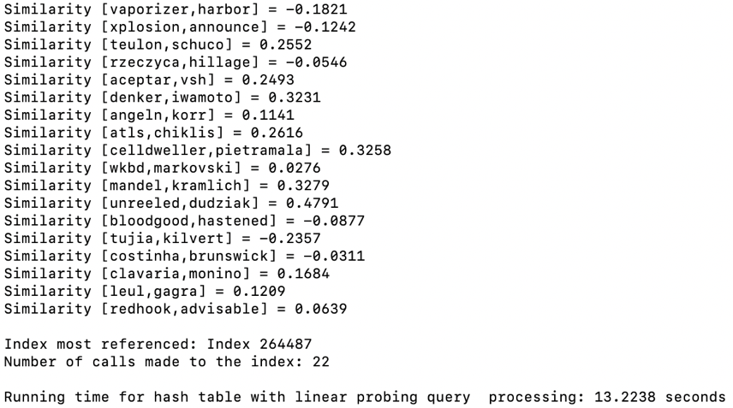

Case 1 (“500 Pairs”):

CTrial1_500.txt

CTrial2_500.txt



Case 2 (“5,000 Pairs”):

CTrial1_5000.txt

CTrial2_5000.txt



Case 3 (“50,000 Pairs”):

CTrial1_50000.txt

CTrial2_50000.txt





The graph above demonstrates the runtimes for finding the similarities of 500, 5,000, and 50,000 pairs of words using hash tables with chaining. In these tests, the individual chains were not ordered so a regular linear search was conducted. From the graph it is evident that the ascii sum hash function and ascii first and last hash function had the lowest runtimes. This is attributed to the fact that it is less common for words to have the same letters. For example, words like “anna” and “nana” are less likely to occur. Hashing string lengths, on the other hand, would virtually result in the same hashing value being used continuously. After evaluating the shorter runtimes for the two hash functions, they were then populated by the glove.6B.50d.txt file. The ascii sum hash function was able to finish building at around 40 seconds. The ascii first and last hash function was implemented but the test was halted after a minute was reached. It is also interesting to note from the tests conducted above that the string length function could only reach a search for 50,000 word pairs. A larger file size was tried, but the test was stopped due to the long runtime. Lastly, although the ascii sum may seem efficient, when compared with the other data using the standard hash function, it has the longest runtimes.

**Load Factor – Finding Similarities:**

For the Load Factor- Finding Similarities test, four tests were run. Case 1 through Case 3 focused on finding the similarities of 5,000, 50,000, and 300,000 pairs. Unlike the other tests, the load factors for each test included 0.9, 0.75, 0.5, and 0.27. It is also important to note that the tables with runtimes for a load factor of 0.75 are not displayed since the data was already included in the tests above. As for the four ascii and string length hashing functions for linear probing, they were only included in Case 4. This is attributed to the long runtimes for 50,000 and 300,000 as documented above. The four ascii and string length hashing functions for chaining that utilizes linear search were tested in Case 5. Each test had two different trials with the .txt files corresponding to the trial number. Each .txt file had randomly selected pairs. I thought that this test was very important to identify how the load factor could affect the find functions. The files tested can be found in the GitHub repository under the TestTrialFiles folder.

Sample Output for Hash Table with Chaining:

Length of string hash function using glove.6B.50d.txt

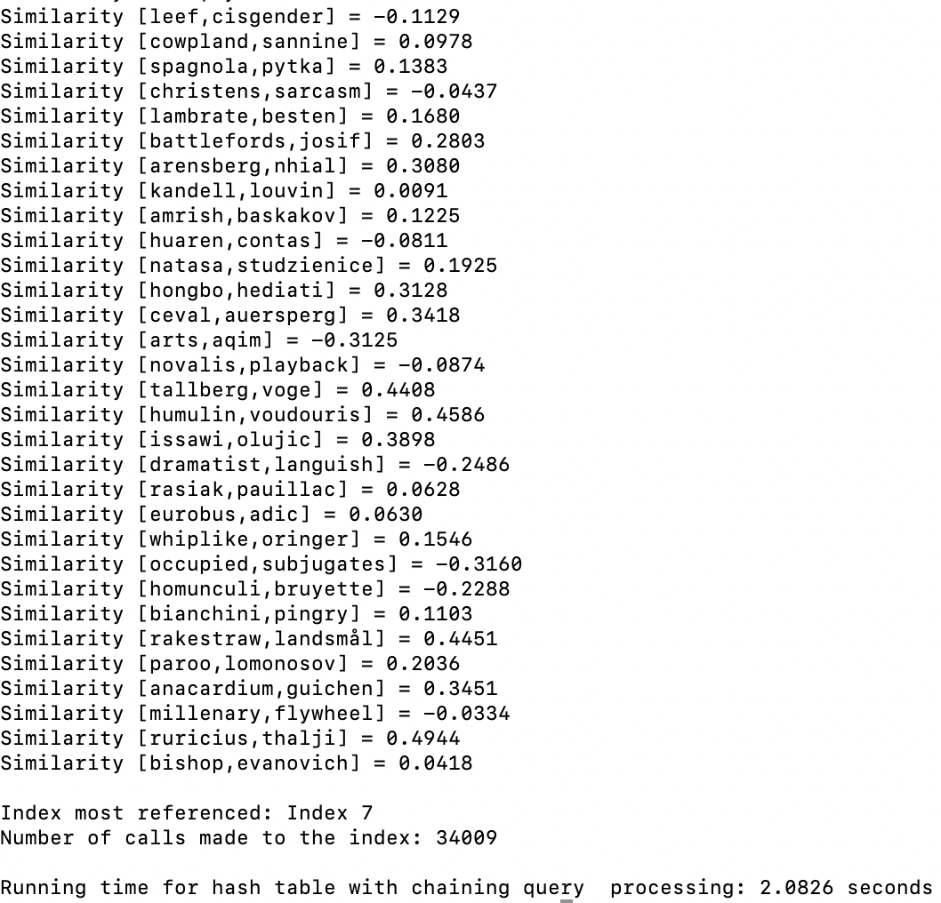

Sample Output for Hash Table with Linear Probing:

Custom hash function using glove.6B.50d.txt

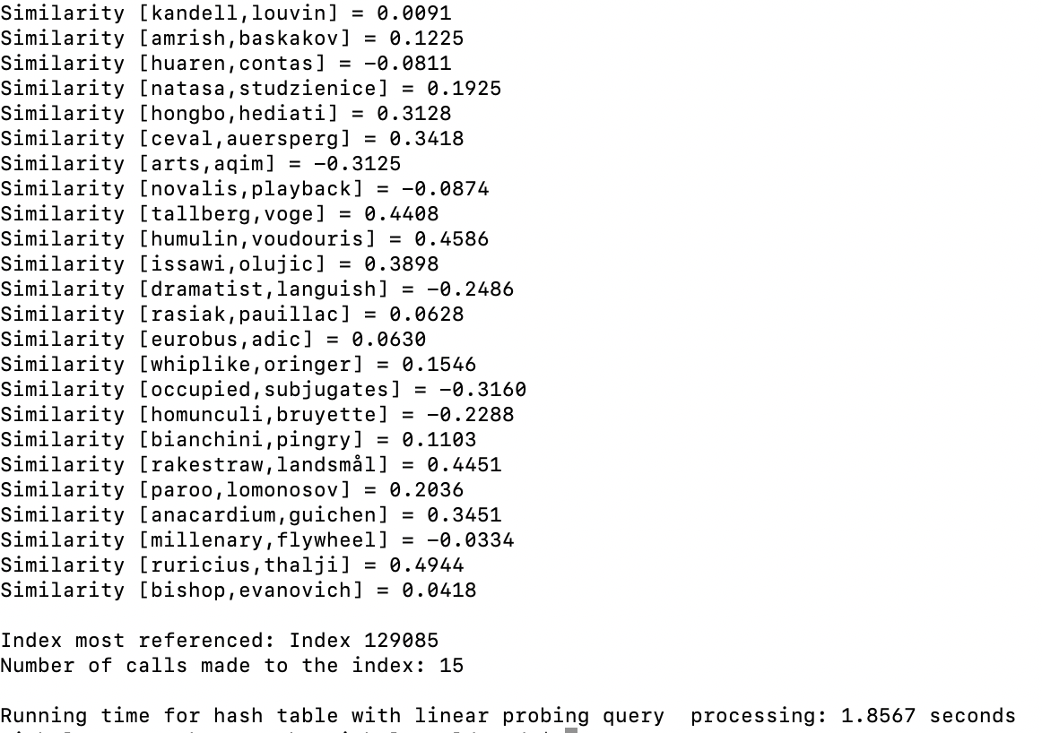

Case 1 (“5,000 Pairs”):

Trial1_5000.txt

Trial2_5000.txt









Case 2 (“50,000 Pairs”):

Trial1_50000.txt

Trial2_50000.txt









Case 3 (“300,000 Pairs”):

Trial1_300000.txt

Trial2_300000.txt









Case 4 (“Hash Table Linear Probing - 35% of Words”):

LPTrial1_500.txt

LPTrial2_500.txt









Case 5 (“Hash Table Chaining Using Linear Find – 45% of Words”):

CTrial1_50000.txt

CTrial2_50000.txt









The graphs above compare the running times from the tests conducted with the running times obtained from previous tests with a load factor of 0.9, 0.75, 0.5, and 0.25. From these tests, the overall effects of the load factors were not noticeable, except for the Linear Probing custom and recursive hash functions. This is probably due to the hash functions themselves. For example, the string length hash function will probably only map to the first ten indices, regardless of whether the table size increases. This results in approximately the same amount of collisions, and therefore the same amount of running time, regardless of the load factor. As for the running times for the linear probing recursive and custom functions, the runtimes are longer due to the data’s distribution. By inserting the WordEmbeddings so closely together, more collisions occur resulting in longer searching times. It is also interesting to note that for the ascii and string length hash functions with ordered chains, the runtimes for the load factor of 0.9 were actually lower than the other runtimes. This is a result of the binary insertion. Since the elements were inserted in order, binary search can be used to retrieve the elements. Hash functions 1 through 4 all result in larger chains. Thus, by constantly halving the data through binary search, the faster runtimes are apparent. Although the load factor of 0.75 did sometimes have larger runtimes, it is still the optimal load factor. The largest difference between the load factor of 0.5 and 0.75 was approximately two seconds. These two seconds are more favorable then the empty ﻿327,092 buckets that occurs with the load factor of 0.5. For the string length, the load factor of 0.9 had the highest runtime. The difference between the runtimes for search was approximately 0.10 seconds whereas the difference between construction times was about 14 seconds. Thus, 0.75 is the optimal choice when compared to 0.9 because it not only has faster construction times but can also find an element at approximately the same time as the hashing tables with a load factor of 0.27. Additionally, the dramatic difference between the linear probing with a load factor of 0.9 and the chaining with a load factor of 0.9 is also attributed to the insertion methods. For the hash table with chaining, a binary insertion is performed, allowing the data is the bucket to repeatedly be halved. For the linear insertions, each bucket has to be checked one by one until the word is found. Lastly from Case 5, it is evident that the as the load factor decrease, the running time decreases. This is a result of how the linear search works. Rather than continuously halving the data, each element in the chain is viewed one by one until the correct element is found.

**Maximum Index Reference:**

For the maximum index reference test, one test was run. This test focused on identifying the maximum number of times an index was referenced during the search operations. For the four linear probing functions and the four hashing functions for the chaining with linear search, the maximum number of times an index was referenced was based on a search for 2000 word pairs. For the other functions, the maximum number of times an index was referenced was based on a search for 150,000 pairs of words. I thought that this test was very important to identify the distribution of the data. I specifically chose these file sizes of 150,000 and 2,000 since they were central values for the pair sizes. The files tested can be found in the GitHub repository under the TestTrialFiles folder.

Case 1 (“Maximum Index Reference”):

Trial1_150000.txt

LPTrial1_2000.txt

glove.6B.50d.txt



small_glove.txt







From the first bar chart, it is evident that the string length chaining hash function had the most searches tied to a specific index. This is probably because the word sizes do not vary. On average a majority of the words range from 5 to 7 letters. Thus, it is easy to identify why an index was being called more than 50,000 times. Although the index was dramatically referenced more than the other indices, the function’s runtime was very similar to the runtimes of the linear probing’s hashing functions. The recursive hash function had the lowest index references. This is clearly apparent in the hash functions overall lowest runtimes. As the second graph demonstrates, the string length hash function had the highest index references. Additionally, both the linear probing and chaining hash functions had the same max number of indices referenced. This is expected since the same files were used. For example, the string length hashing function will divide the string length by the size of the table. In most instances, the length of each word is approximately 7. Thus, 7 would be mapped to index 7 from a hash table with 8 buckets to a hash table with 300,000 buckets. In all tests, the recursive hashing function and custom hashing functions had the lowest index references.

**Running Time Comparisons for BST, B-Trees, and Hash Tables:**

The graphs below compare the running times for BSTs, B-Trees with max_data of 5 and 499, and hash tables. The bar chart demonstrates the running times for the construction of the data types. The first graph shows the growth in runtimes for 2,000 pairs to 5,000 pairs. The second graph shows the growth in runtimes 50,000 pairs to 100,00 pairs. The third graph shows the growth in runtimes for 150,000 to 300,000. I thought that comparing the data structures based on the number of pairs was crucial for the overall analysis. Since 0.75 was the load factor that was able to produce fast finds and insertions while minimizing the amount of space needed, its runtimes were selected for the final analysis. For the hash tables, the hash functions 5 and 6 for linear probing and chaining with unordered chains were selected. They offered the best and most consistent runtimes. The only other hash function that could be compared was the ascii sum. However, it had extremely long runtimes and search times resulting in its omission from the overall analysis.









Out of all the running times, the B-Tree with a max data of 5 had the worst running time. This is because the B-Tree not only has a height that it has to traverse, but also a list of elements within a designated node. The hash table with chaining recursive function had the overall lowest runtime. As the first graph demonstrates, initially, all the data structures have very similar running times. As the number of pairs increases, the efficiency of the recursive function clearly shines. An ideal hash table would have found and inserted elements in constant time. With Horner’s method, this “ideal” solution is almost achievable. Whereas the B-Tree or BST have to traverse the height of the tree, the hash table looks for the bucket where the element should reside in constant time. As for the BST, its runtimes were generally the second highest. Since the BST had a height of 47 nodes, at most 47 nodes needed to be compared. As for the hash functions, some, like the recursive function, only needed to evaluate two or three items before finding the correct word embedding. As for the custom hash functions, the running times were generally in the middle of all the other running times. For the small, average, and medium files, the custom hash function had lower performance times than the BST and B-Trees. Additionally, based on the running times for the hash table with chaining ascii functions, the hashing functions still obtained lower runtimes than the trees. The linear probing hashing functions with ordered chains were omitted from the final graphs since they used binary insertion. However, looking at the tables of data, the ascii functions all had running times below ten seconds for 300,000 elements. All of the trees for 300,000 had running times above ten seconds. As for the construction, the hash tables had the lowest and highest performance times. Yet again, the recursive chaining had one of the lowest running times. The chaining ascii sum hash function had the highest, reaching nearly 20 seconds. By having a hashing function that mapped multiple values to the same index, the longer runtime is clearly evident. Overall, the hash tables had the fastest implementations for finding similarities and construction times. The hash table with chaining’s recursive method had the fastest running times, proving the superiority of hash tables with the proper hash function. As for the load factor, when considering the construction time and search time, the most ideal load factor would be 0.75. In many of the cases, the hash table with a load factor was able to find the same results in approximately the same amount of time as a hash table with a lower load factor. Additionally, across all the functions, the hash table with a load factor of 0.75 was the most consistent.

**Conclusion**

In all, I learned how to how to transform a program using one data structure to another data structure. I have never had a lab that focuses on implementing the same problem with different data structures, so I thought that this lab was very interesting. By chaining the data structures, I was able to use a lot of pre-existing code from Lab 4. Due to this I learned the importance of having separate methods that perform their own unique task. For example, if I had just decided to group all the methods together in Lab 4, then I probably would have to redo the entire program for Lab 5. By dividing the methods, I was easily able to copy and paste existing lines of code and update any sections as necessary. From this lab I also learned how crucial a good hashing function is for hash tables. If one were to choose a hash function that maps multiple values to the same index, then the running times would be significantly higher. This can clearly be seen from the hash table with linear probing’s ascii function. With a good hash function, like the recursive Horner’s method function, one could create a data structure that could insert and find elements quickly. Although the recursive hash function resulted in faster performance times, I believe that the trees have the most consistent data. For example, when viewing the tables of information from Lab 4, there are not as much spikes in the data. Thus, I learned that while hash tables can be more efficient than trees, collisions can result in unforeseen problems. In all, this lab allowed me to compare trees and hash tables. Prior to the lab, I had only compared the different implementations of the same data structure. By completing this lab, I now realize that there are many different data structures to use for the same implementation. In order to pick the best data structure, one must be more informed. For example, if an individual wanted a consistent way to store and retrieve data without having to worry about collisions, I would recommend a B-Tree. However, if someone wanted an incredibly fast way to store and retrieve data, I would recommend a hash table with the recursive hashing function. I would also note that one must be careful in the event of collisions.

**Appendix A**

**NicholeMaldonado_Lab5.py**

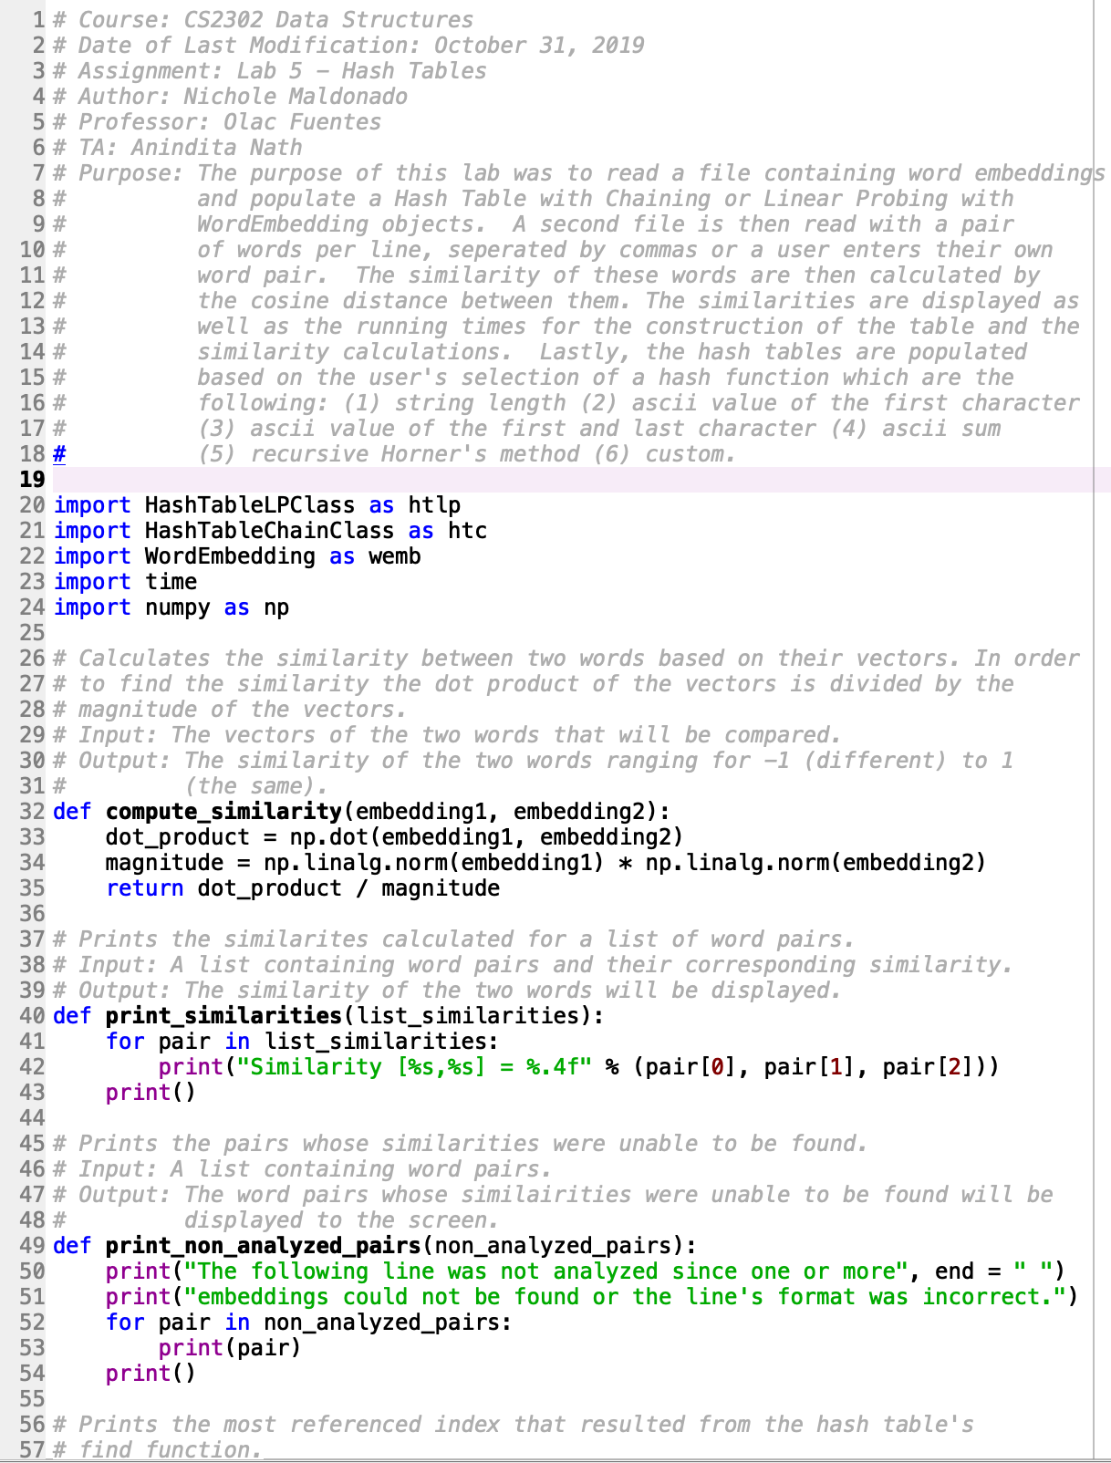

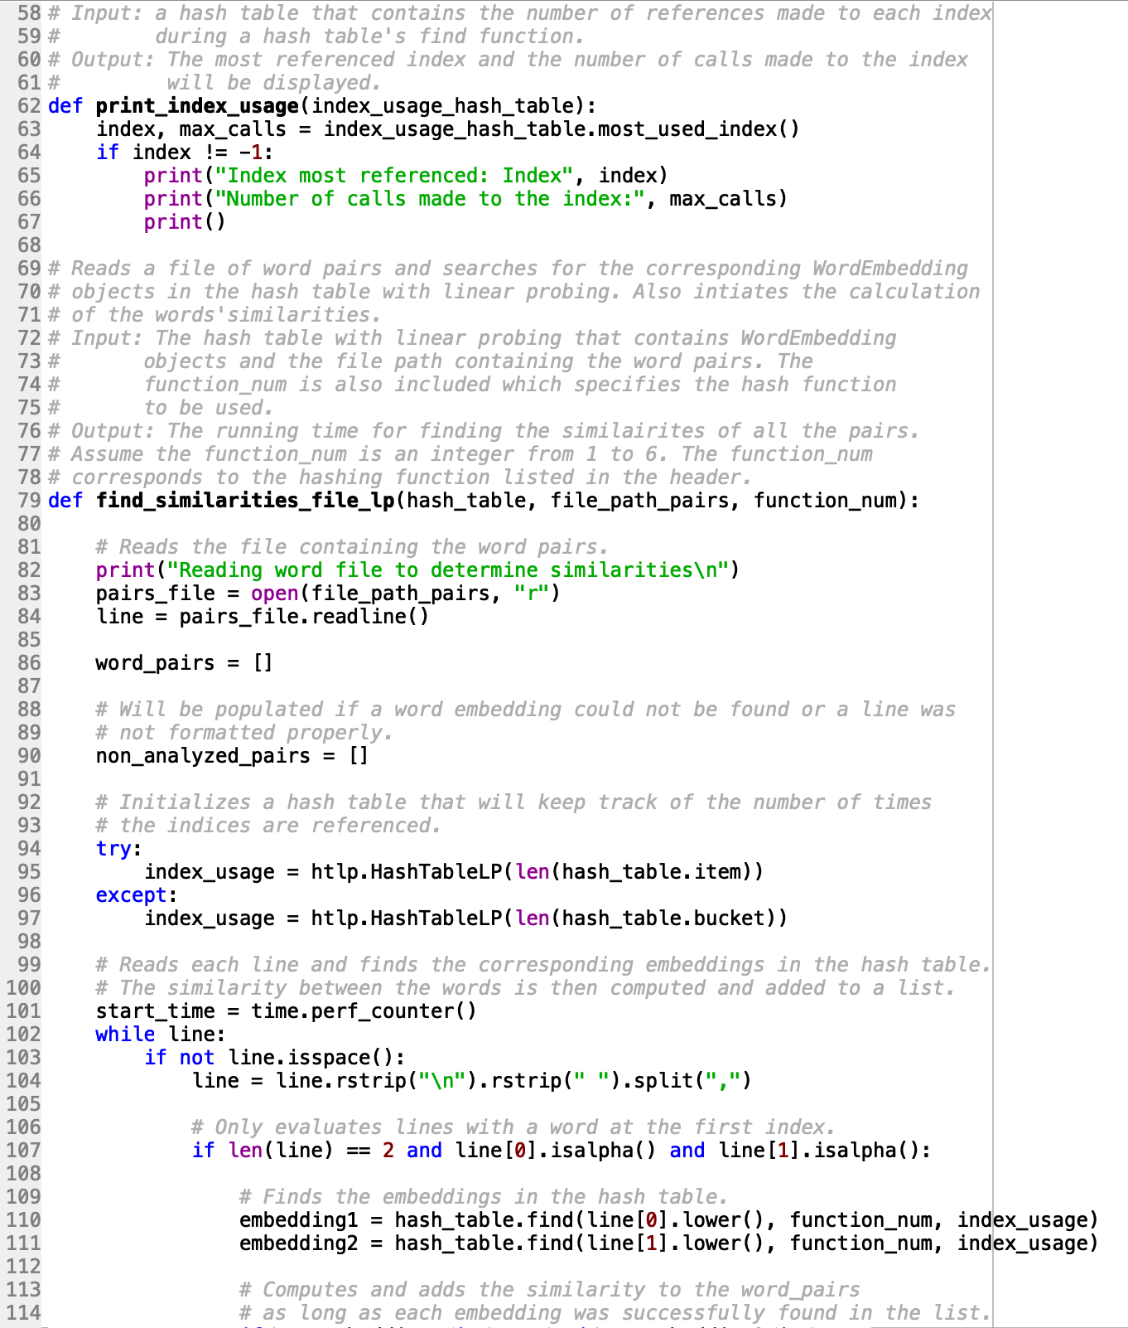

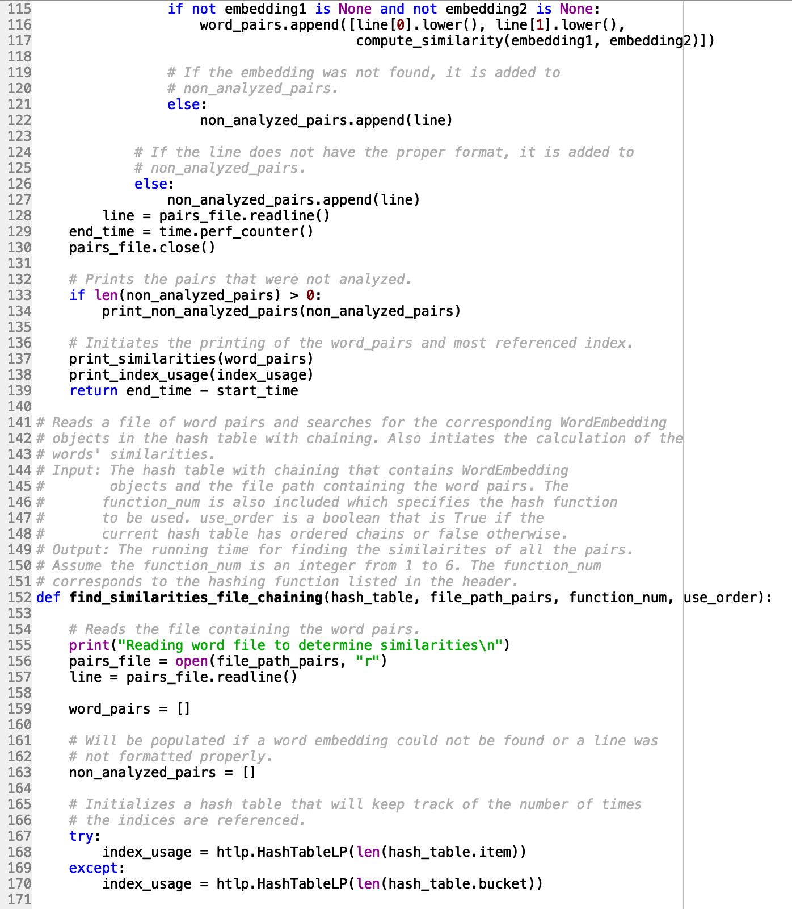

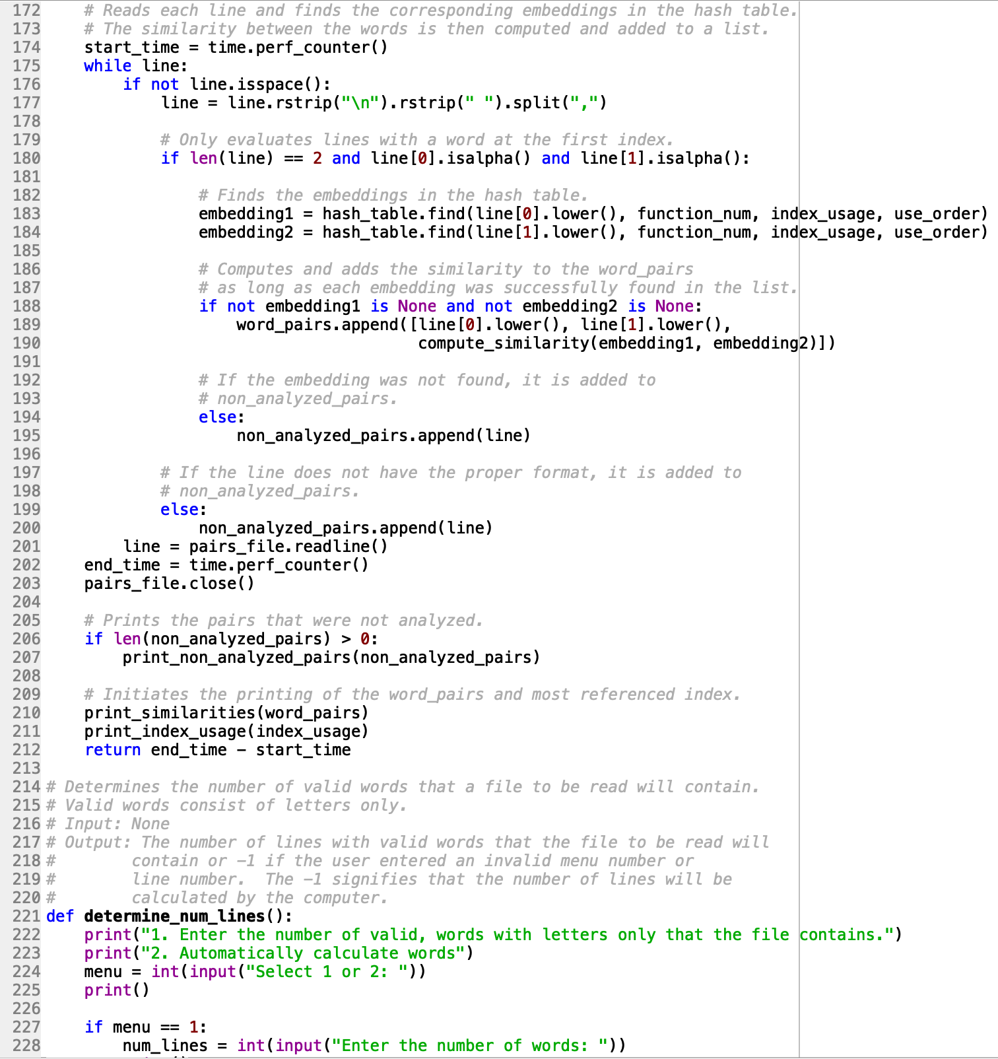

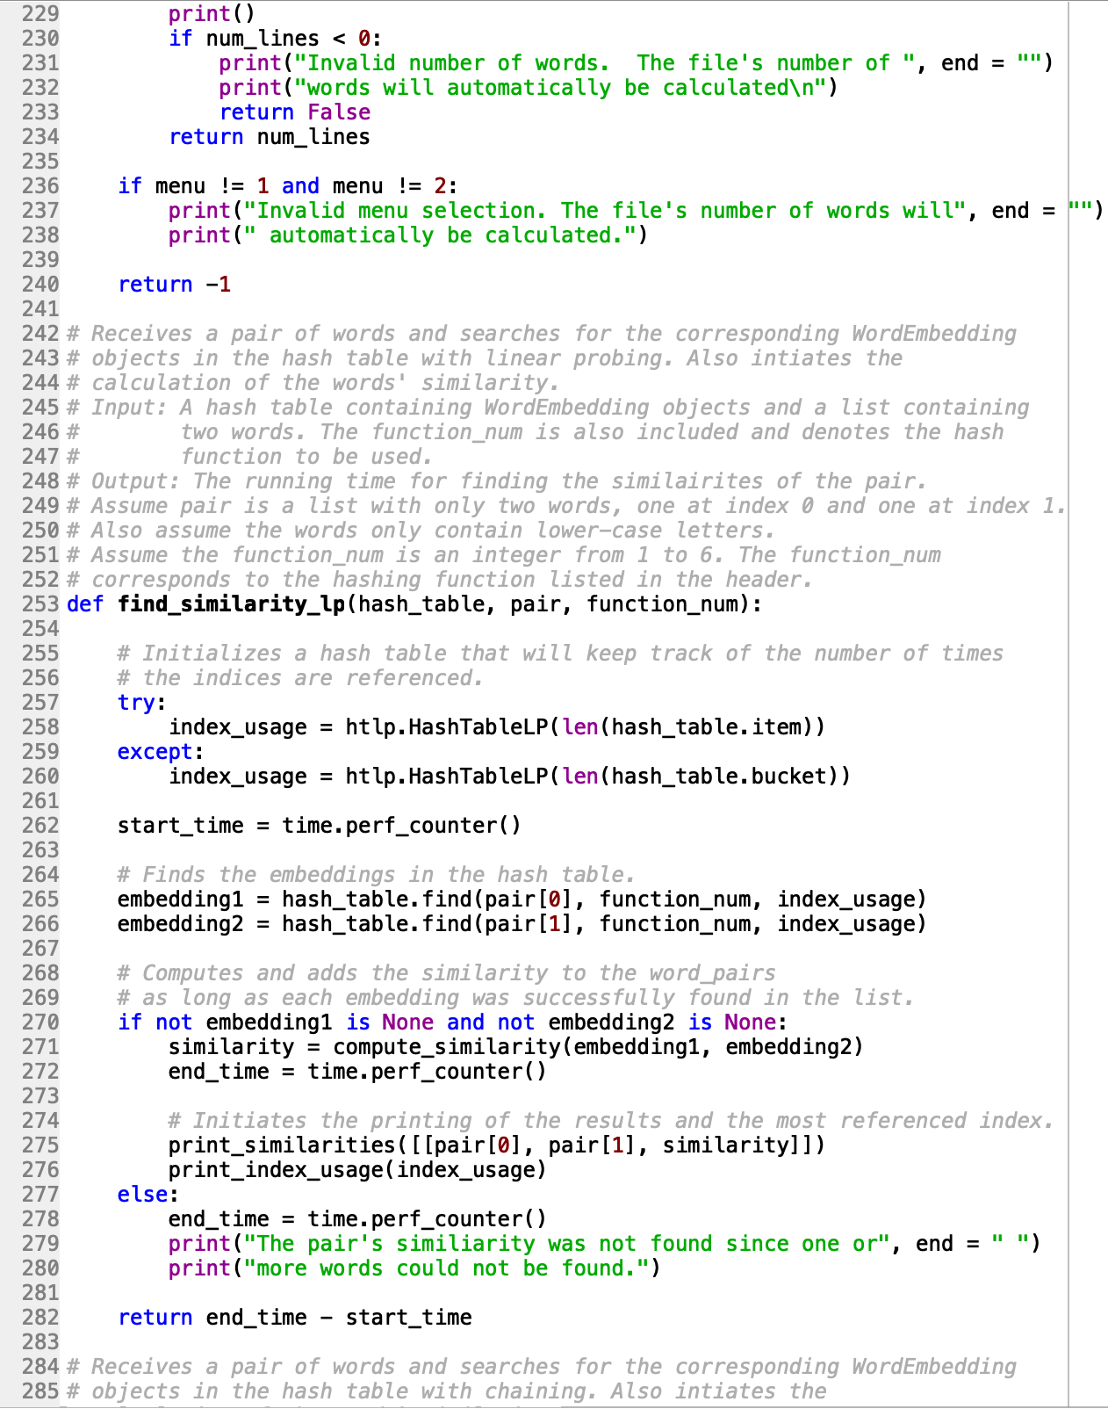

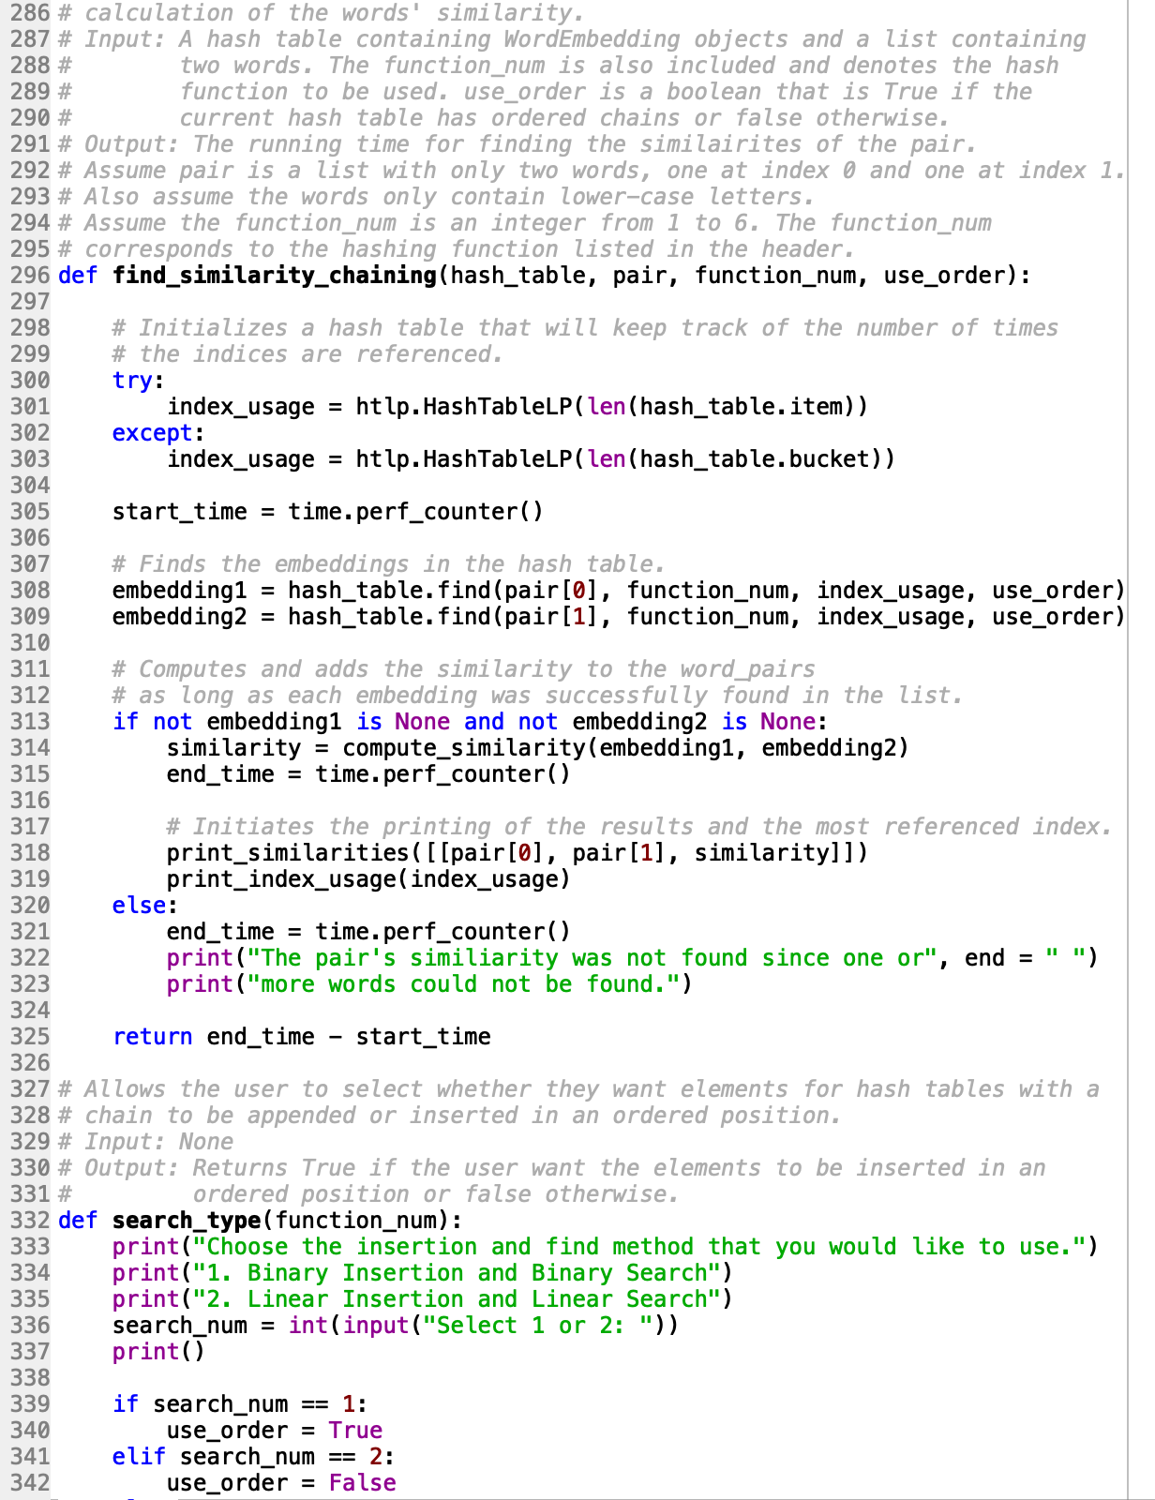



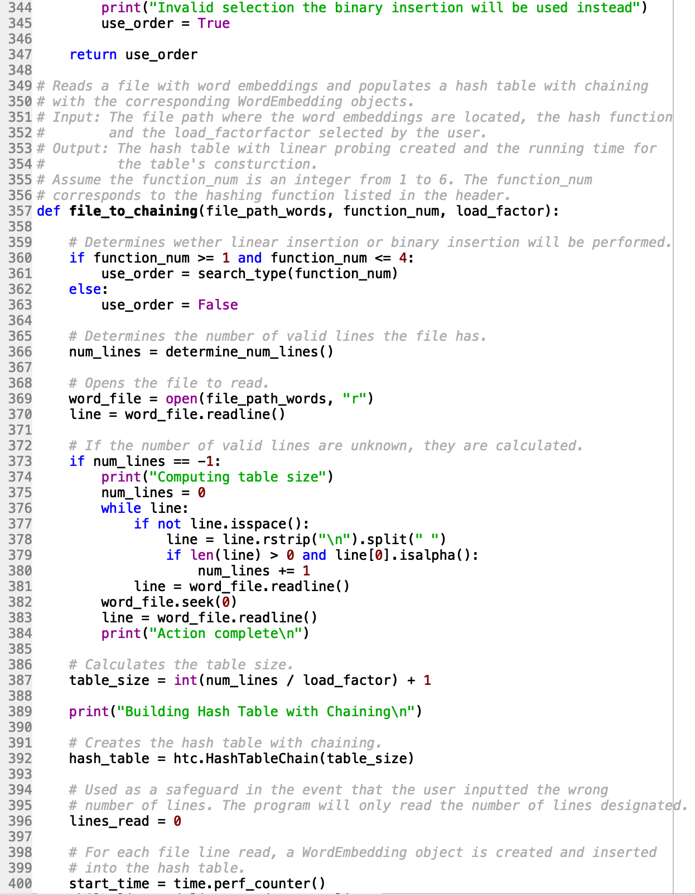

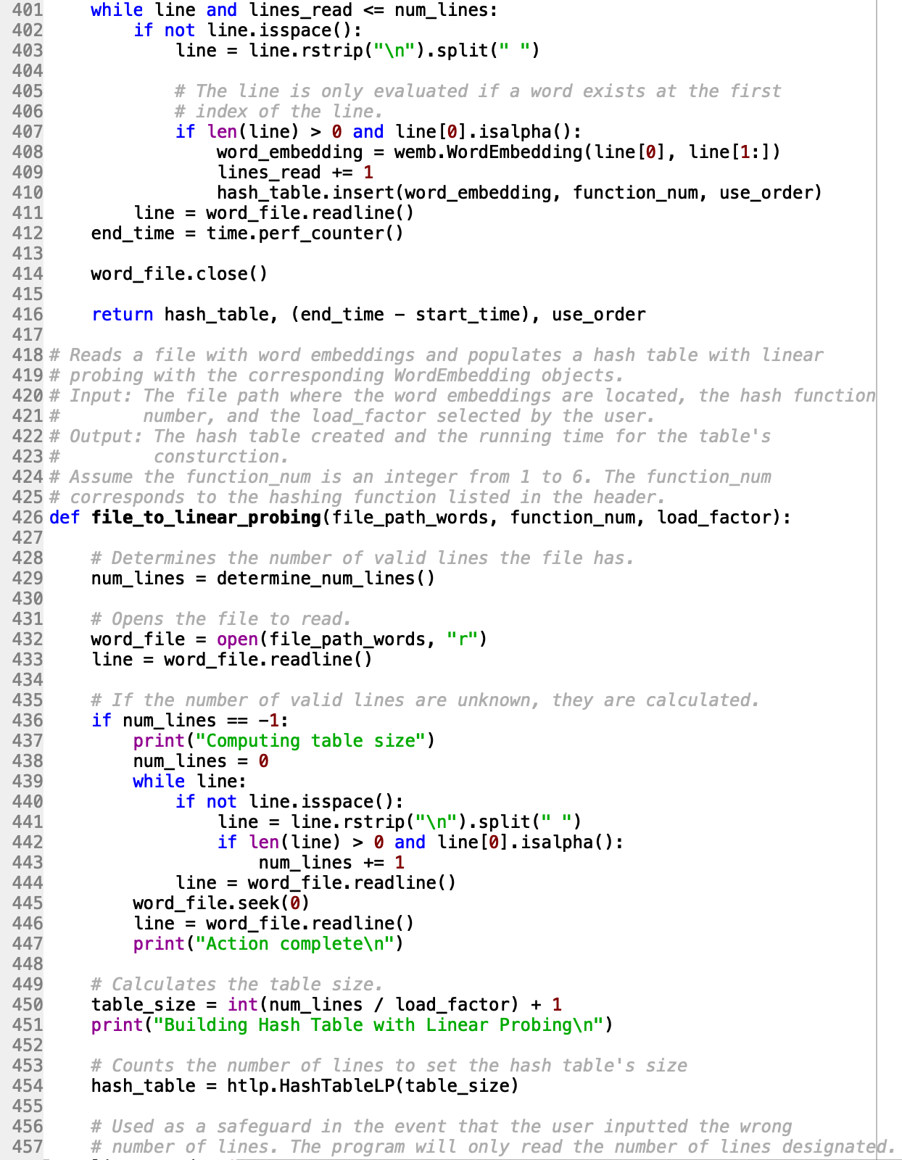

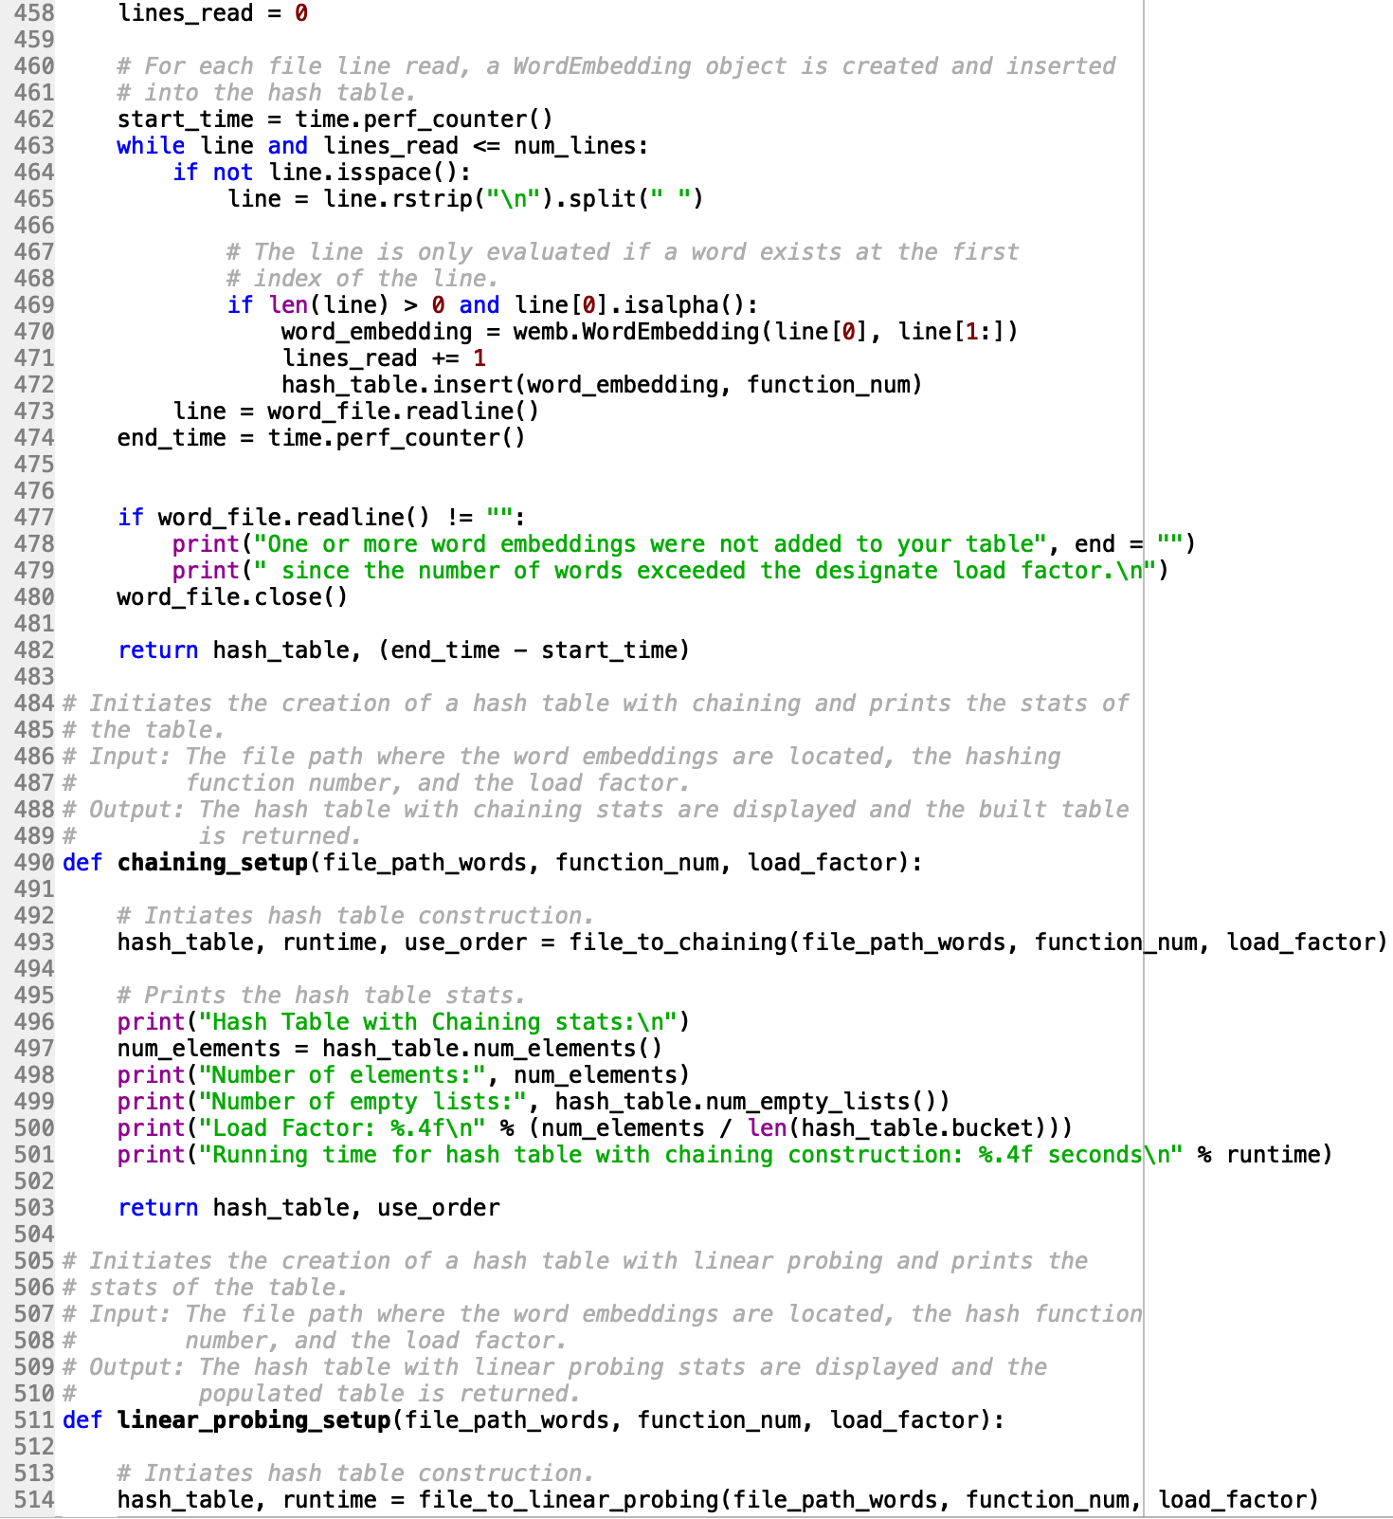

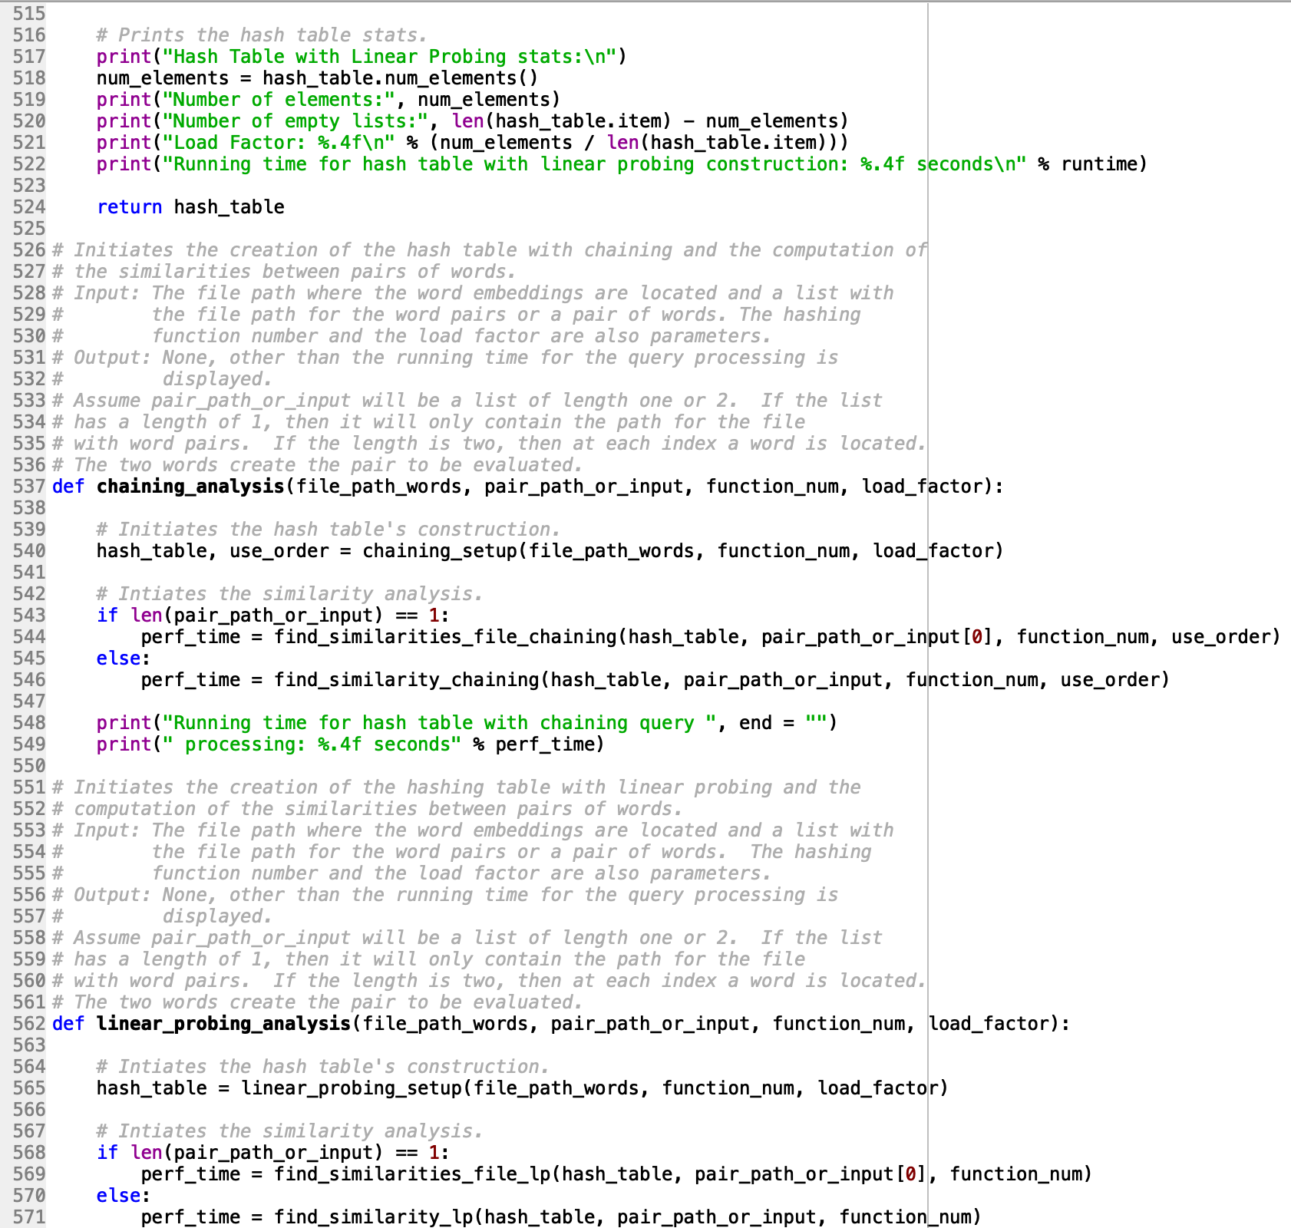

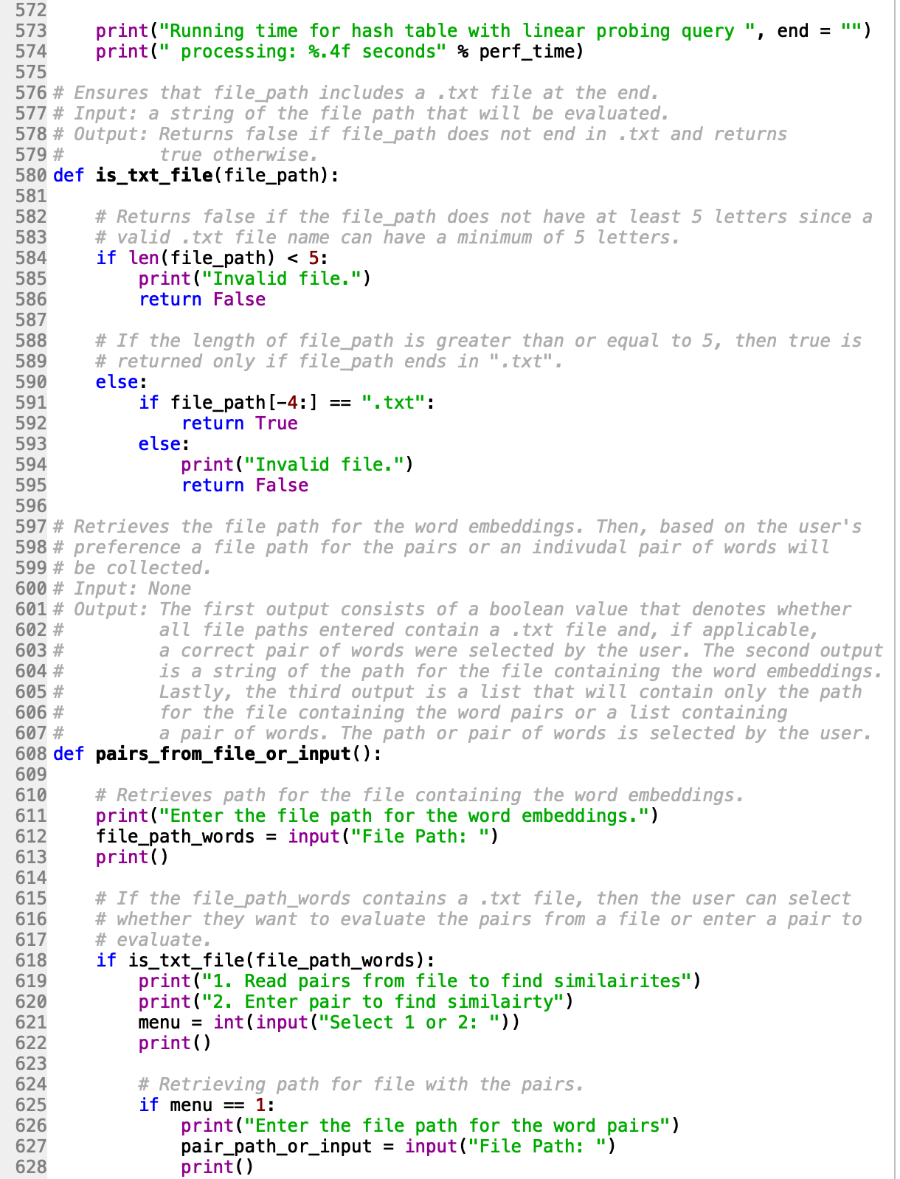

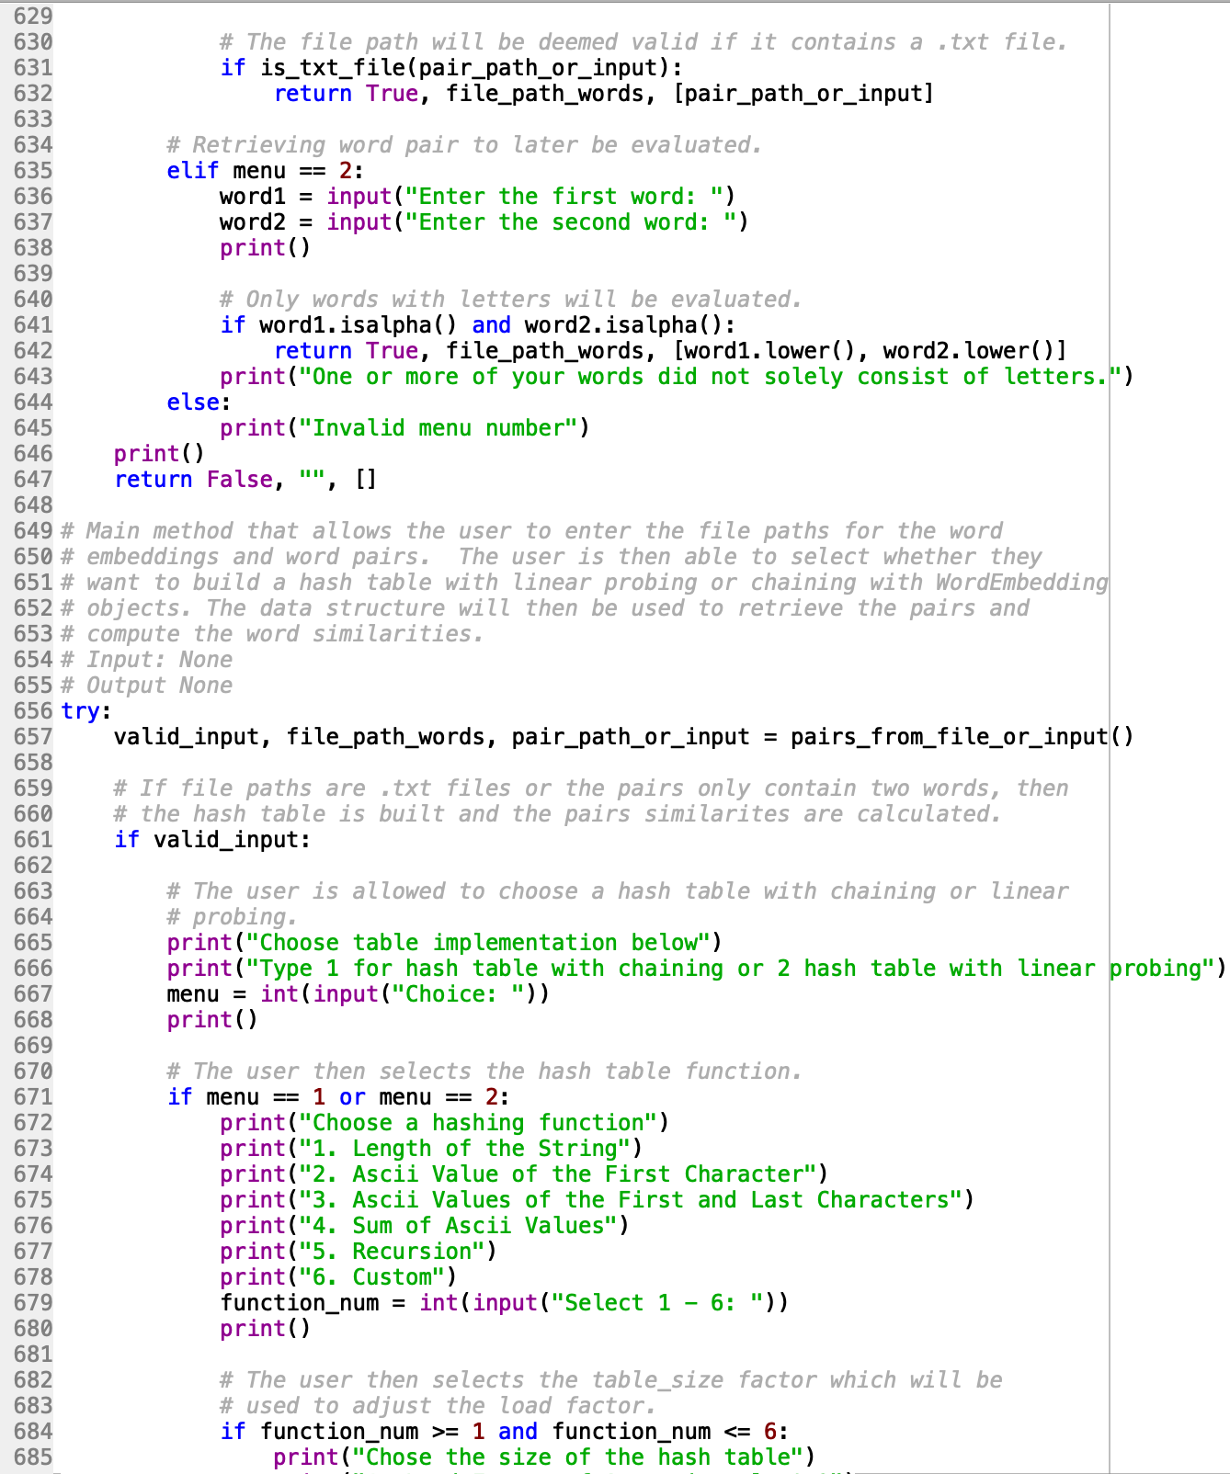

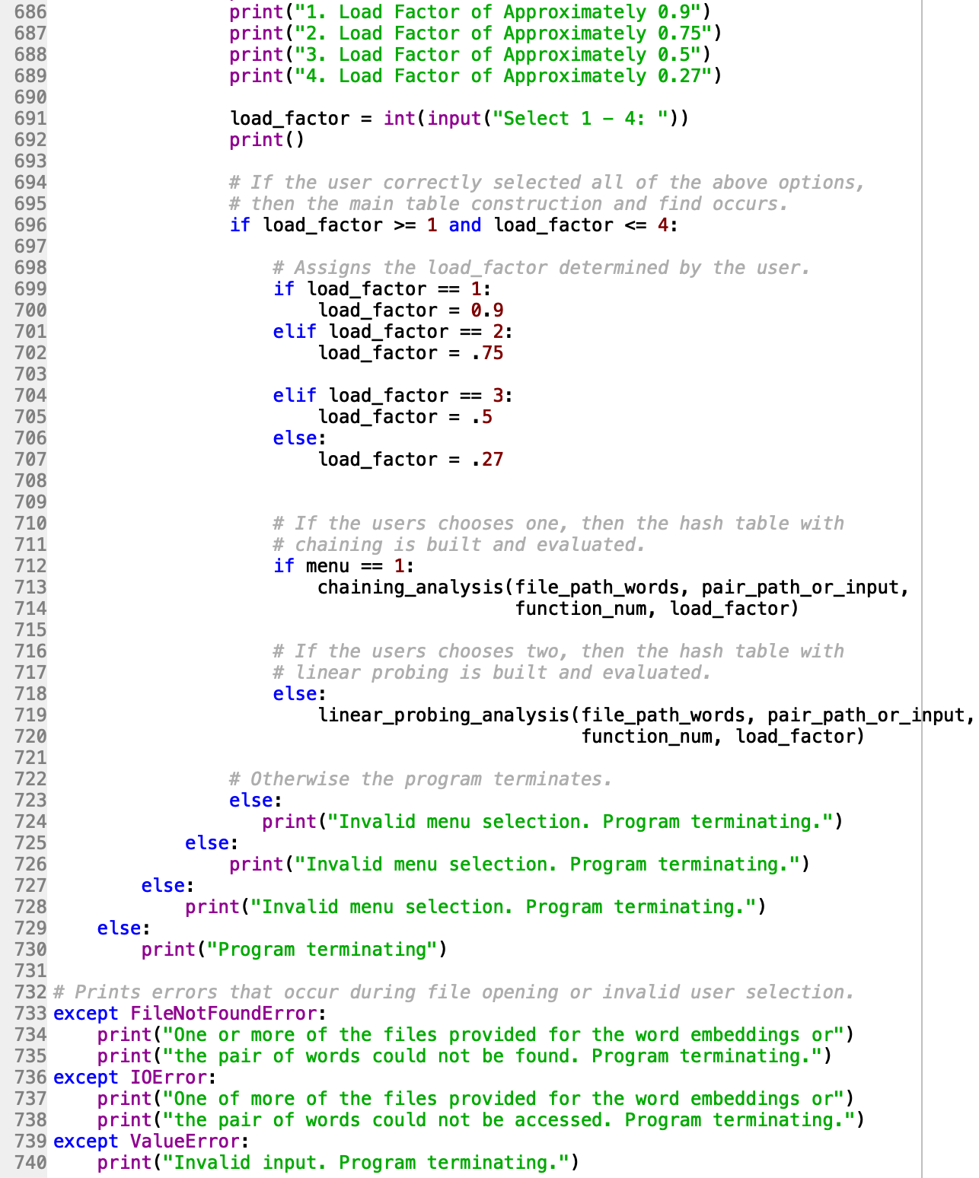

**HashTableChainClass.py**

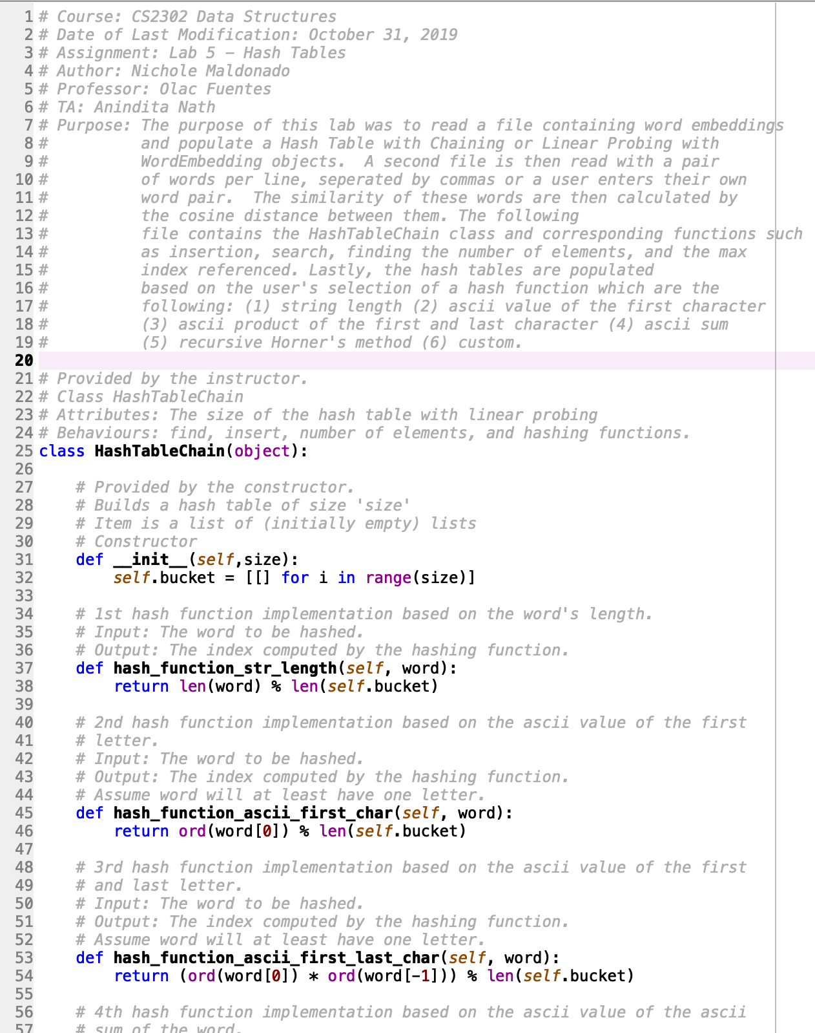

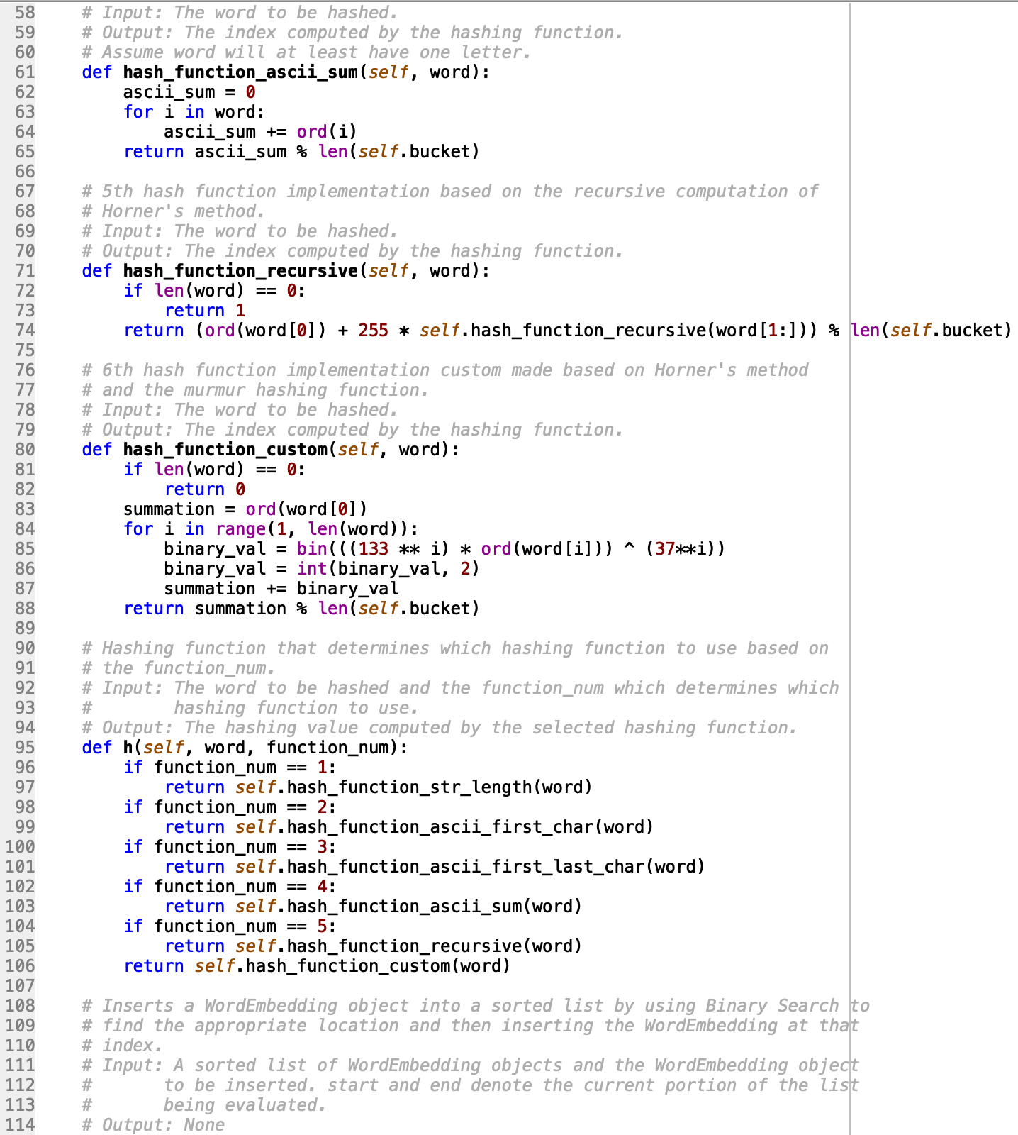

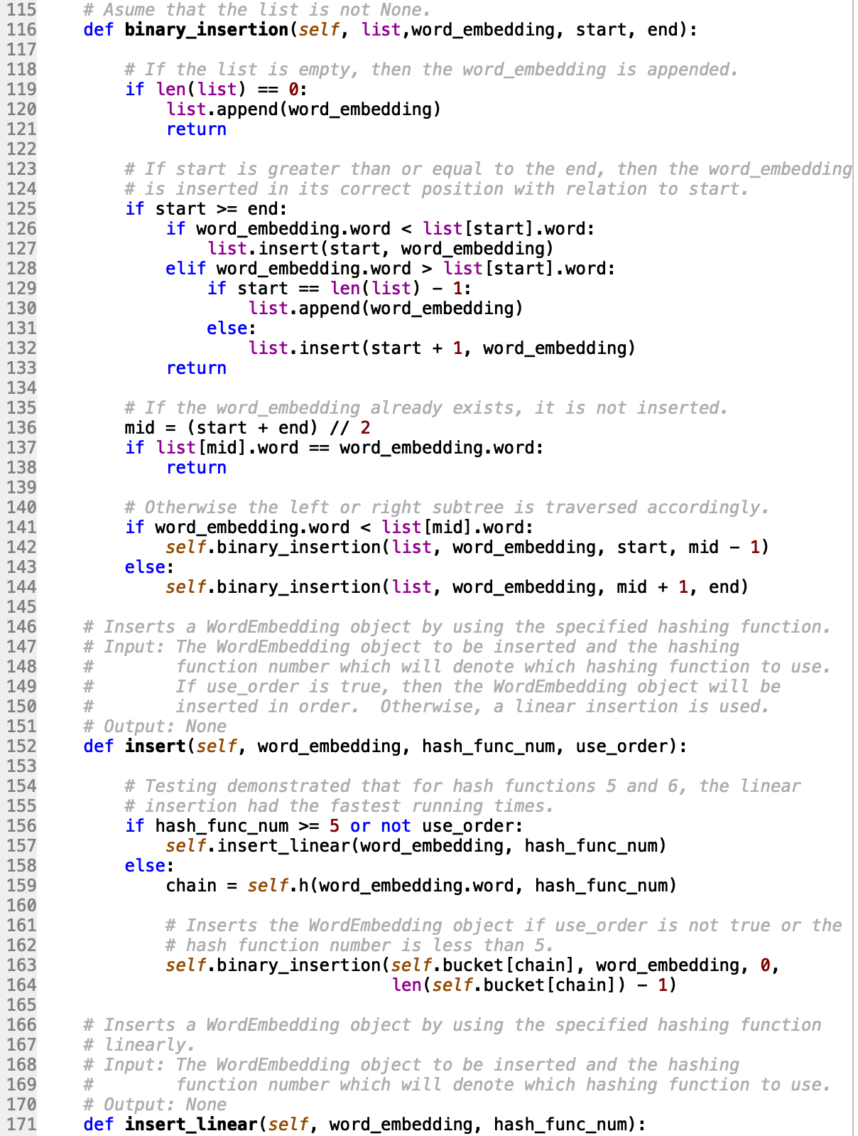

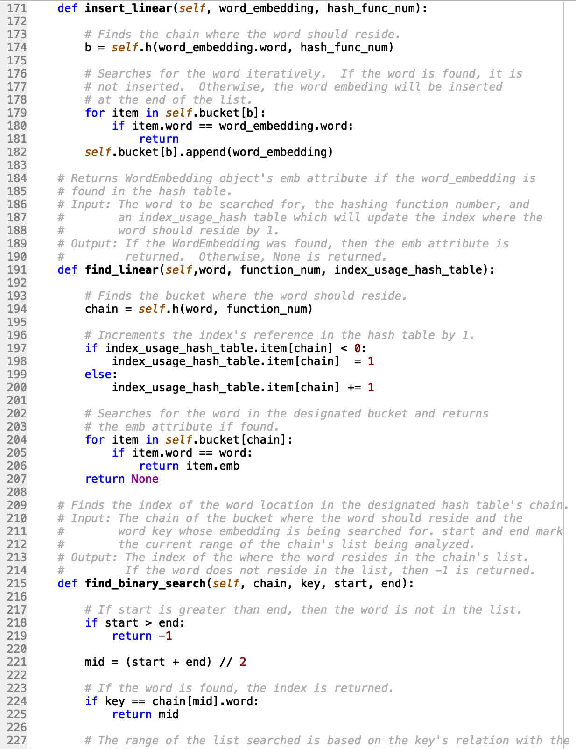

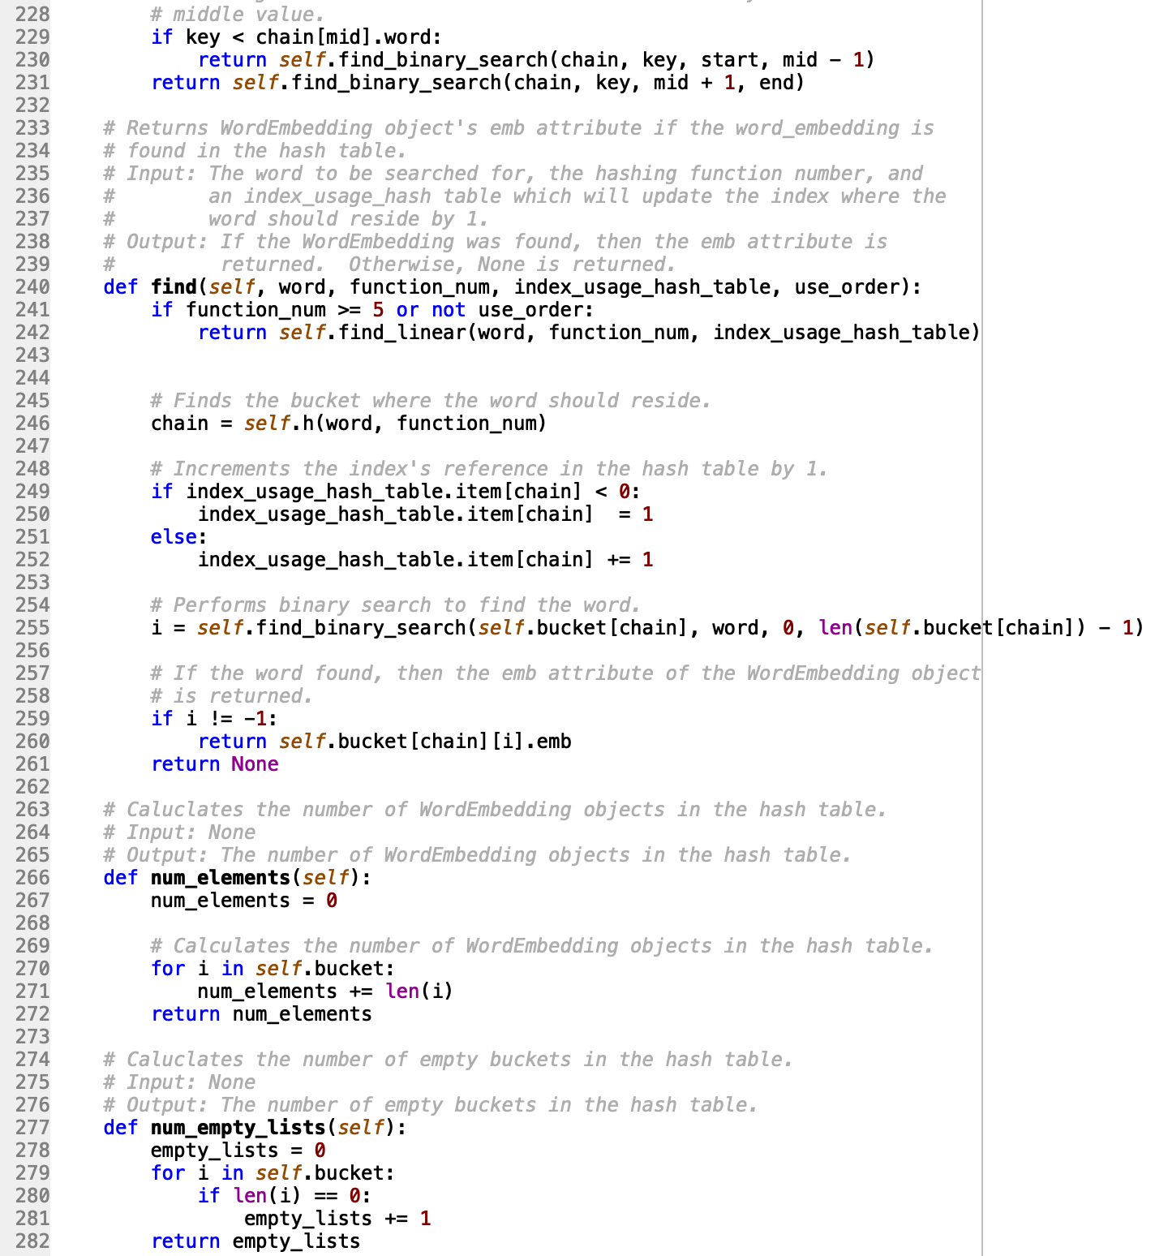

**HashTableLPClass.py**

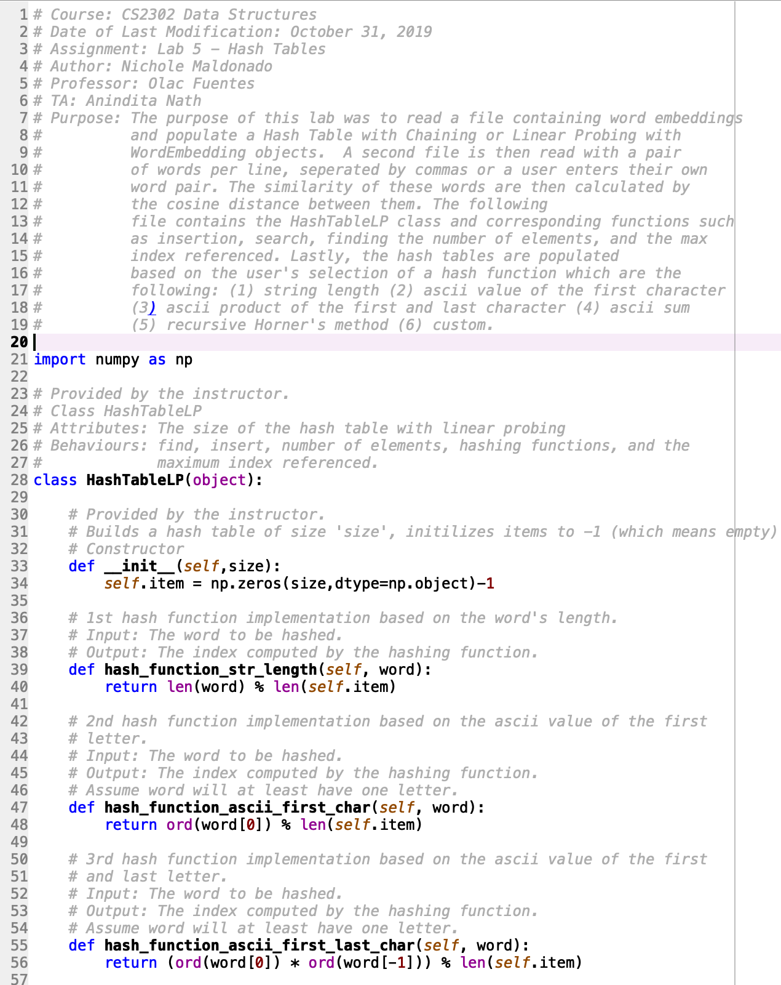

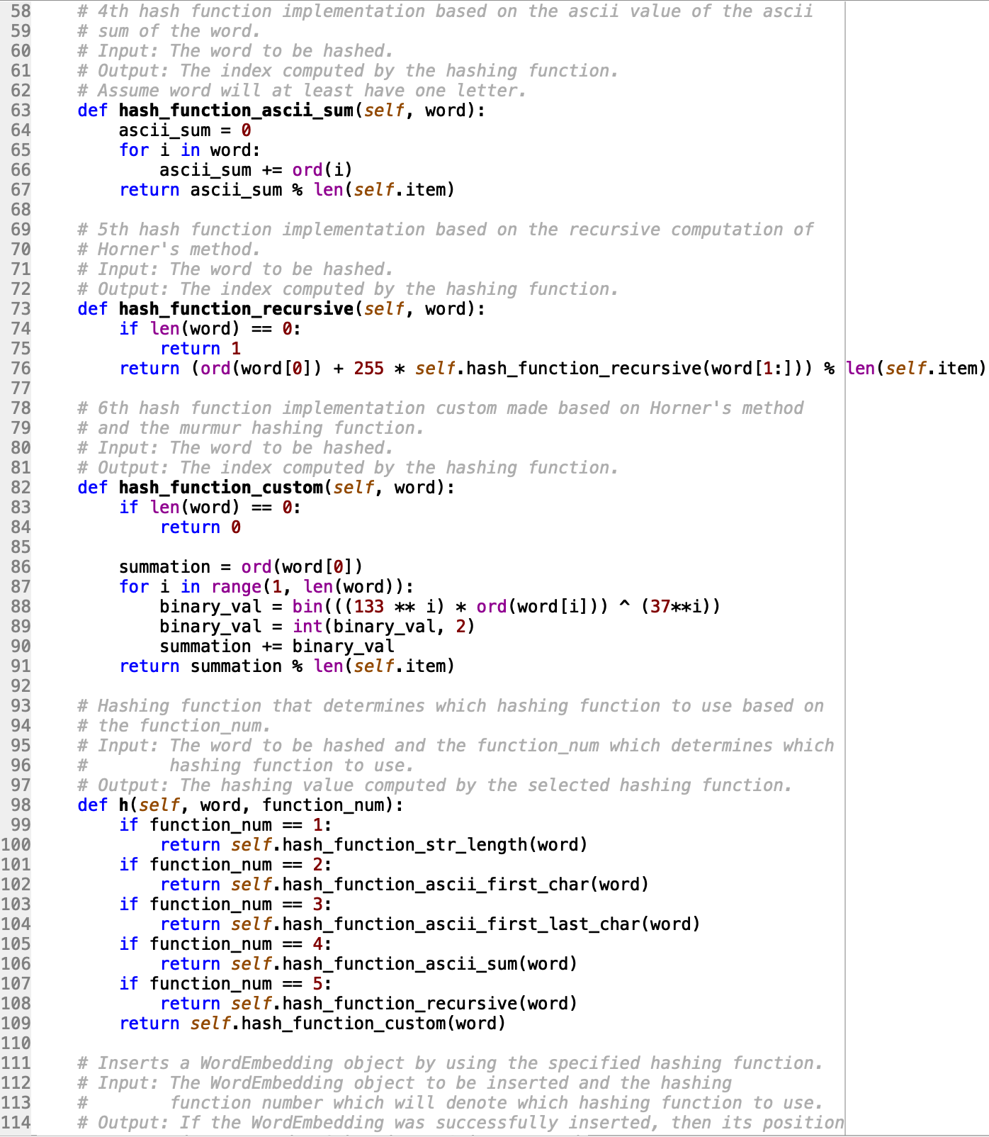

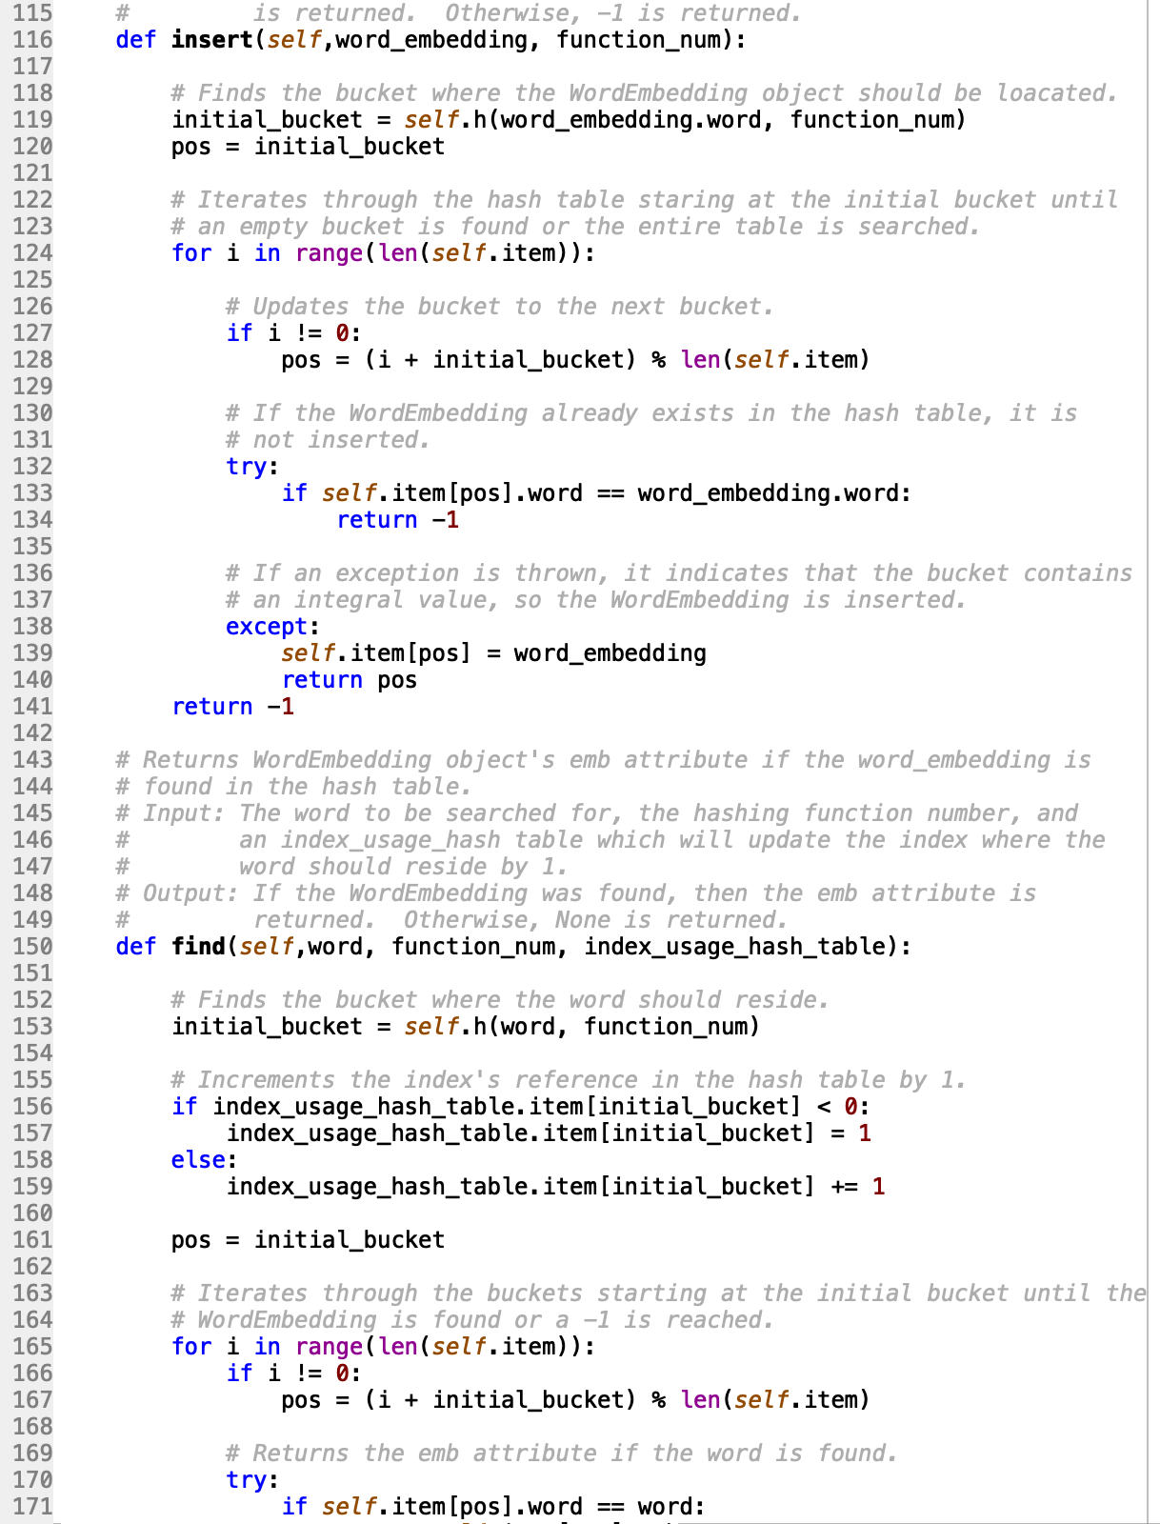





**WordEmbedding.py**

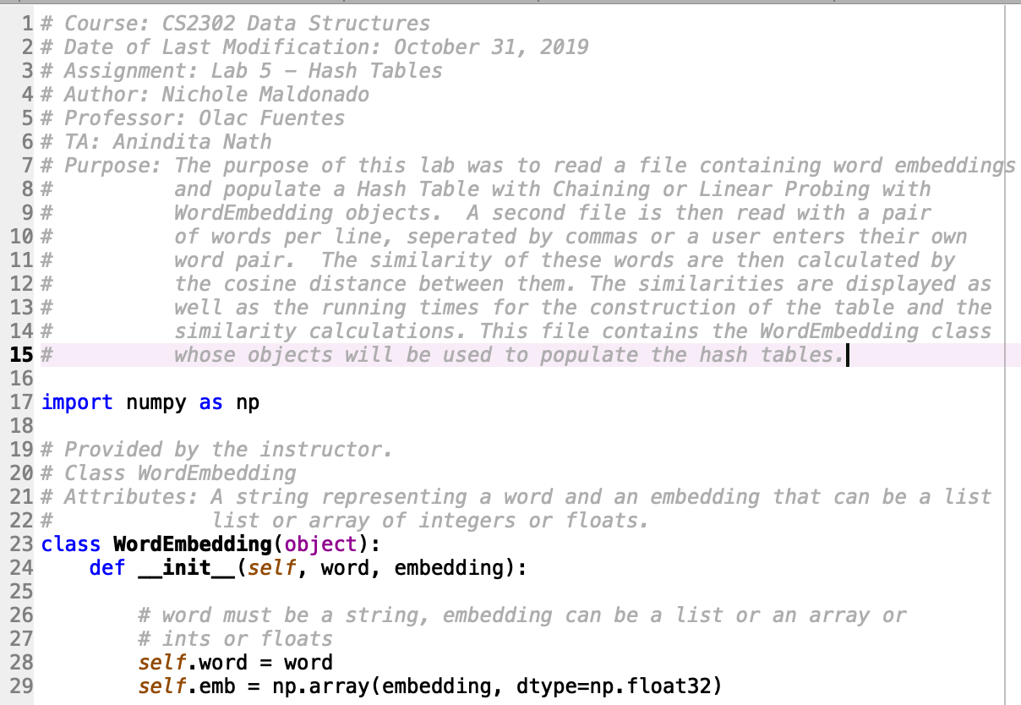

**lp_file_creation.py**

This file was used to create the smaller subsets of the glove.6B.50d.txt file.

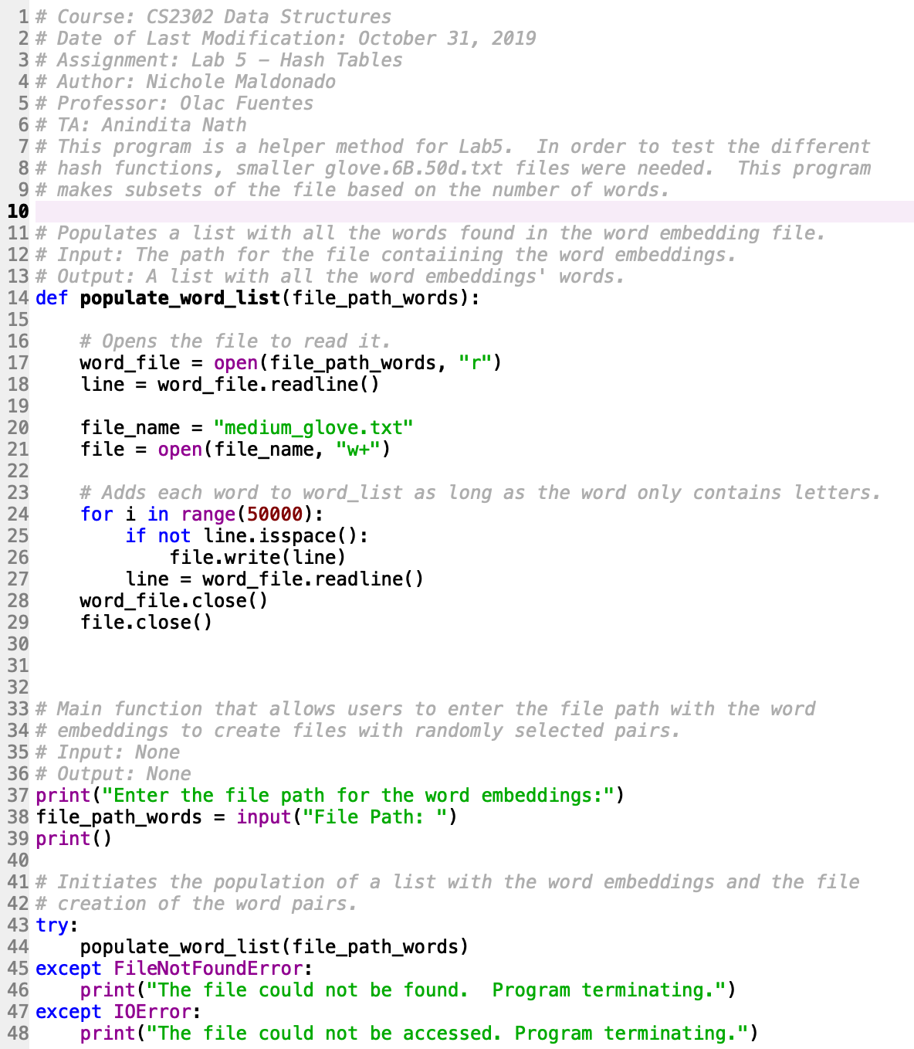

I certify that this project is entirely my own work. I wrote, debugged, and tested the code being presented, performed the experiments, and wrote the report. I also certify that I did not share my code or report or provided inappropriate assistance to any student in the class.

X



-----------------------------------